# How to run

In part I, just run the camera_calibration_3d.m, the result Matlab publish file is camera_calibration_3d.mlx and it can be open in the matlab as **Live Script**.

In part I, just run the camera_calibration_2d.m, the result Matlab publish file is camera_calibration_2d.mlx and it can be open in the matlab as **Live Script**.

In part I, just run the augment_reality.m, the result Matlab publish file is augment_reality.mlx and it can be open in the matlab as **Live Script**.

All three **Live Scripts** will have views in Matlab like below.

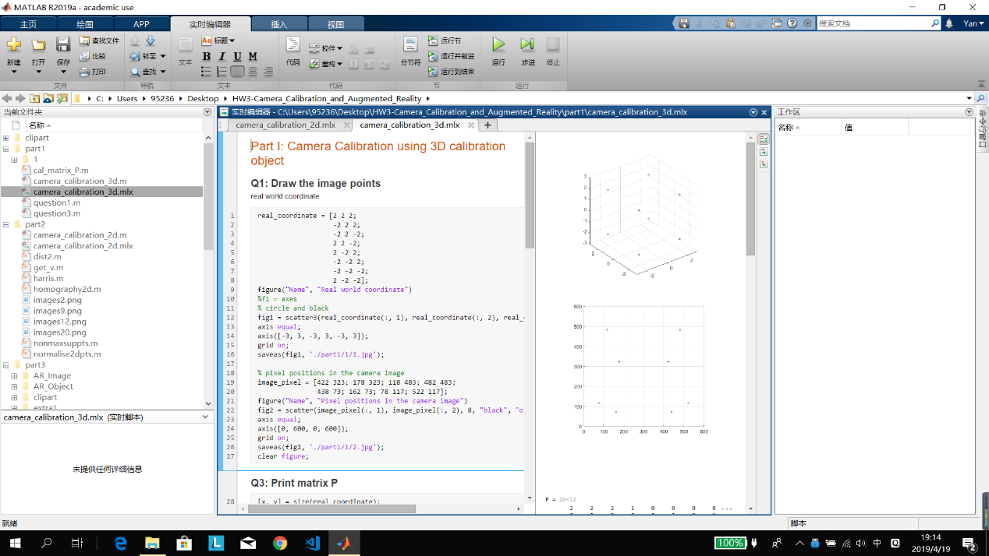

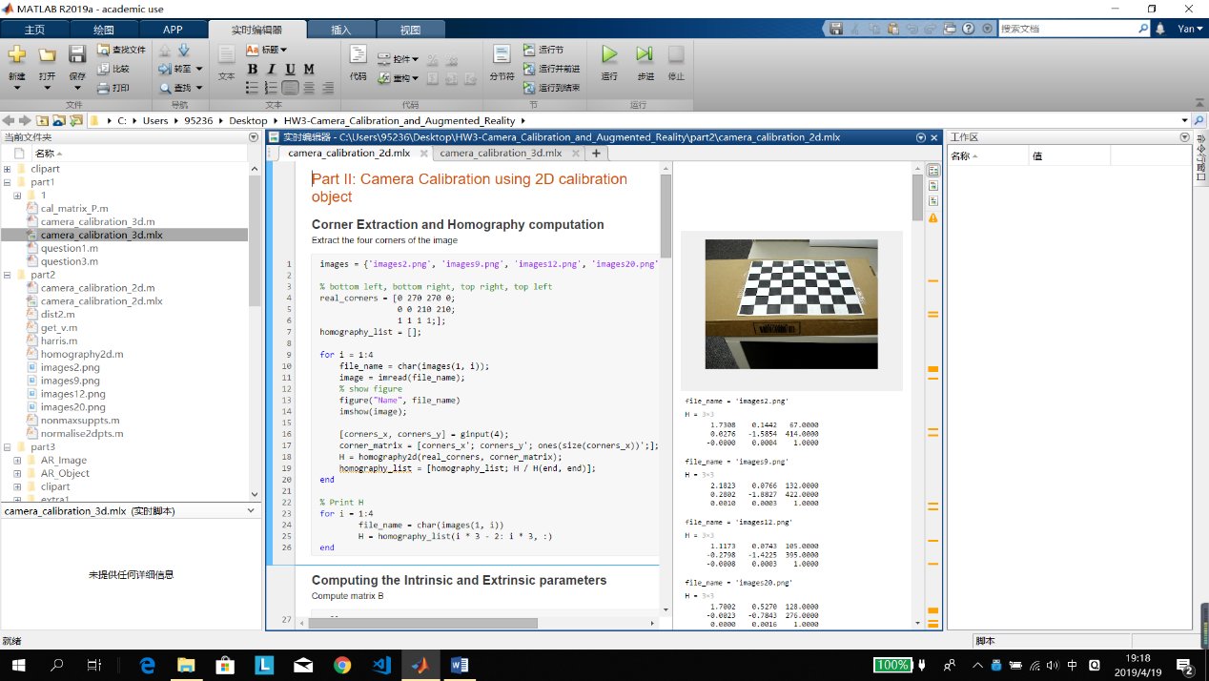

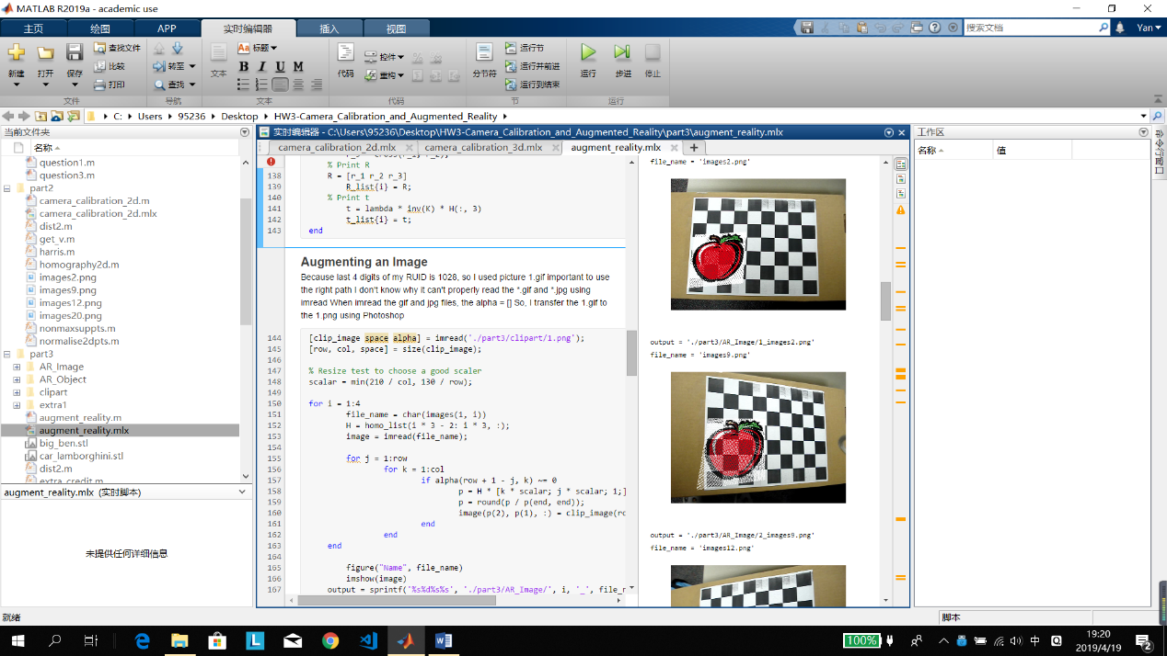

# Part I: Camera Calibration using 3D calibration object

## Q1: Draw the image points, using small circles for each image point.

I have written it in the part1/question1.m and also in the Q1 cell in camera_calibration_3d.m, the following are the results.

**The real-world 3D coordinates.**

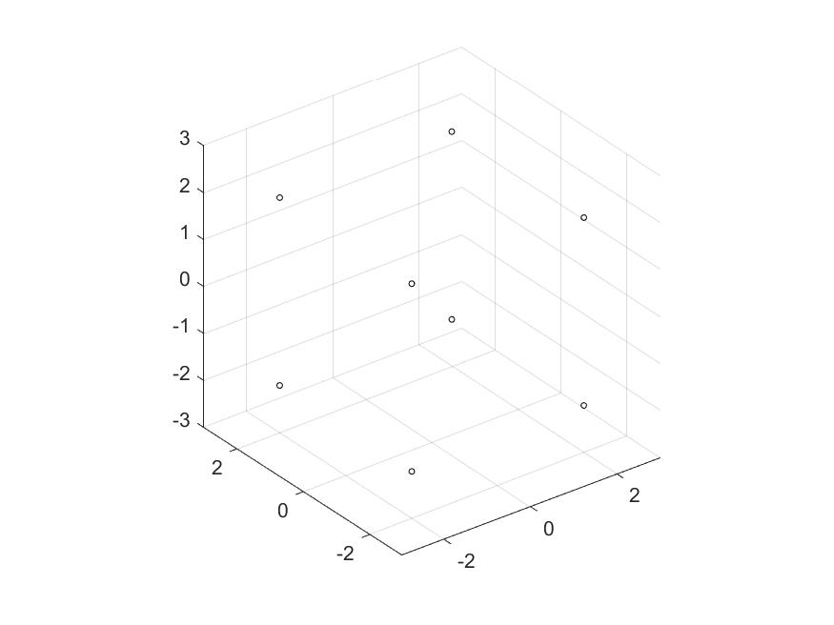

**The pixel positions in the camera image.**

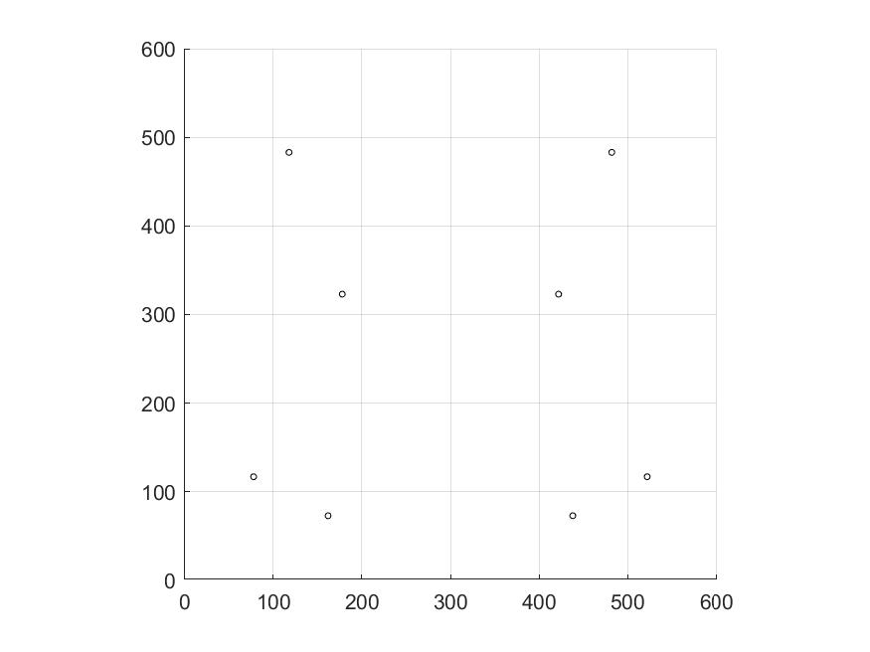

## Q2, Q3, Q4, Q5 and Q6:

The function to generate matrix P is in cal_matrix_P.m

The following is the results.

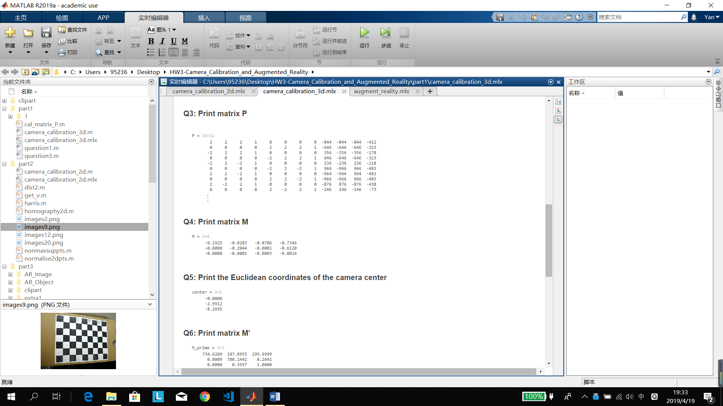

## Q7, Q8 and Q9:

The explanation is in the script.

For Q9,

K = [F_x s C_x;

0 F_y C_y;

0 C_y 1;]

Focal length in pixels = F

Optical center in pixels = C

The results are below.

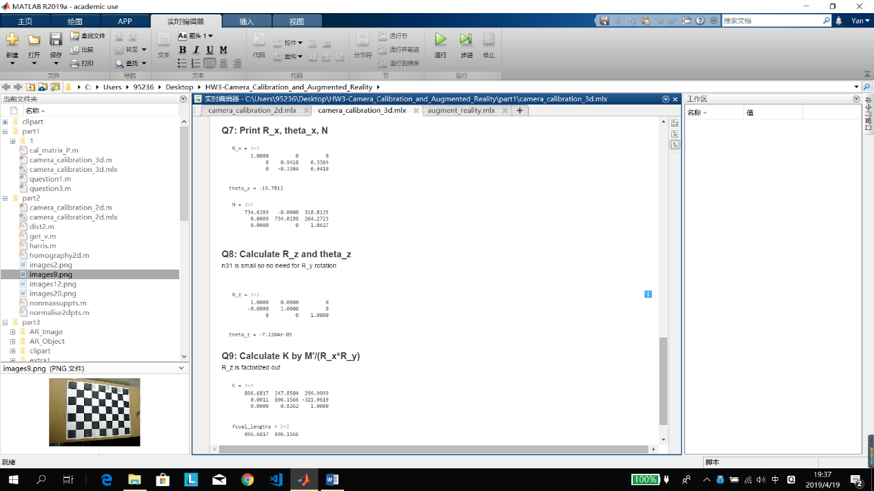

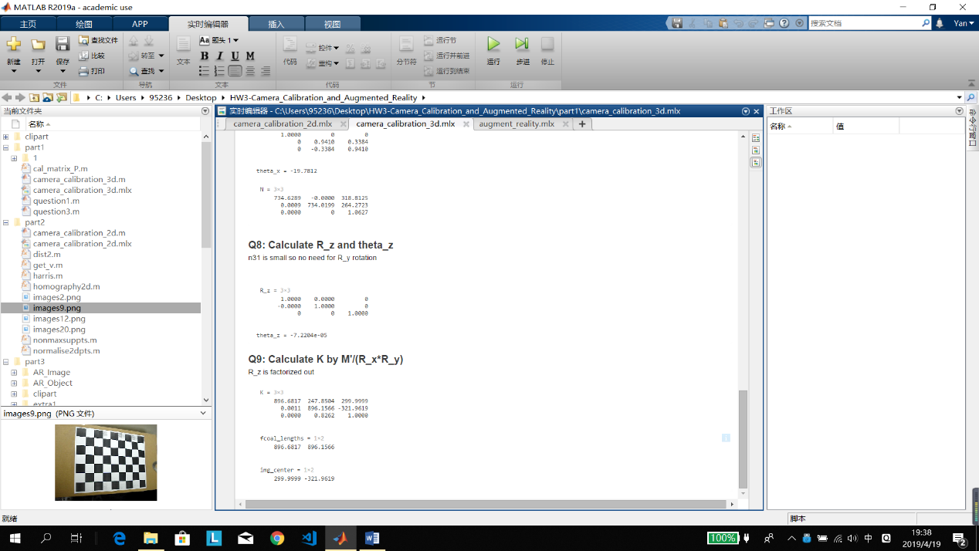

# Part II: Image Inpainting

## Corner Extraction and Homography computation

When using function ginput, please click the image corners in the following order:

Bottom left -> bottom right -> top right -> top left.

The results:

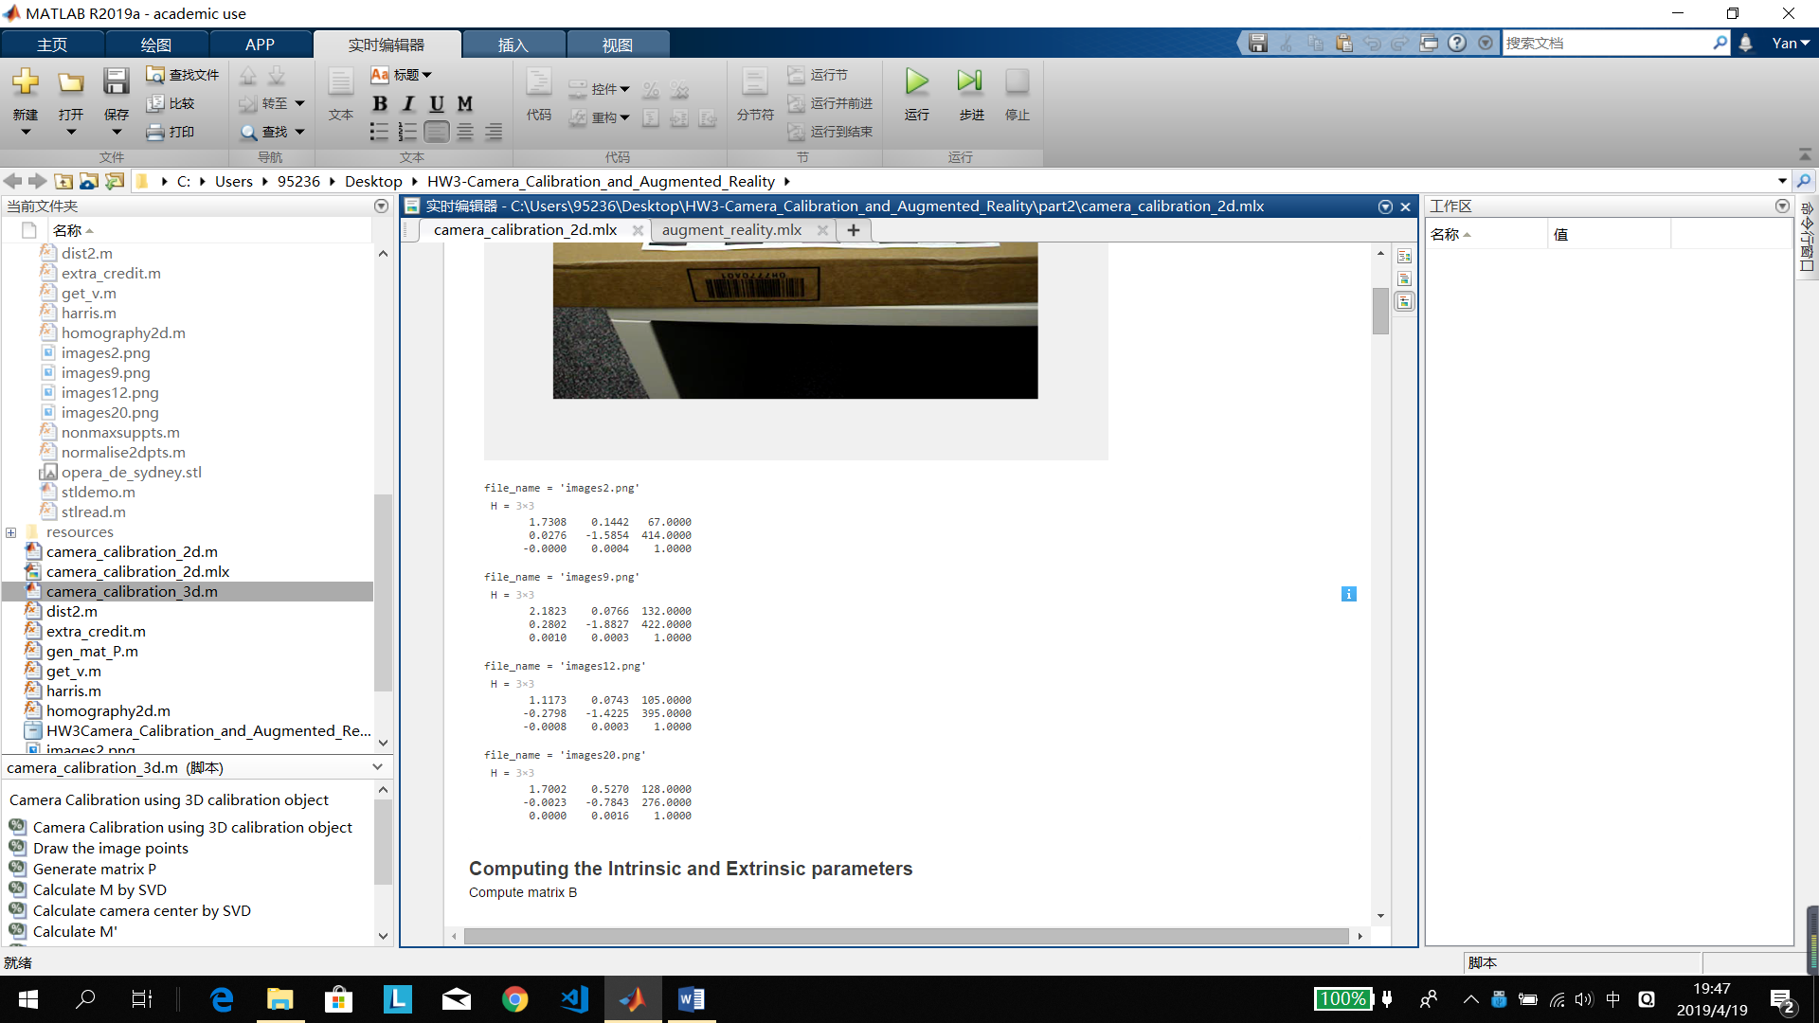

## Computing the Intrinsic and Extrinsic parameters

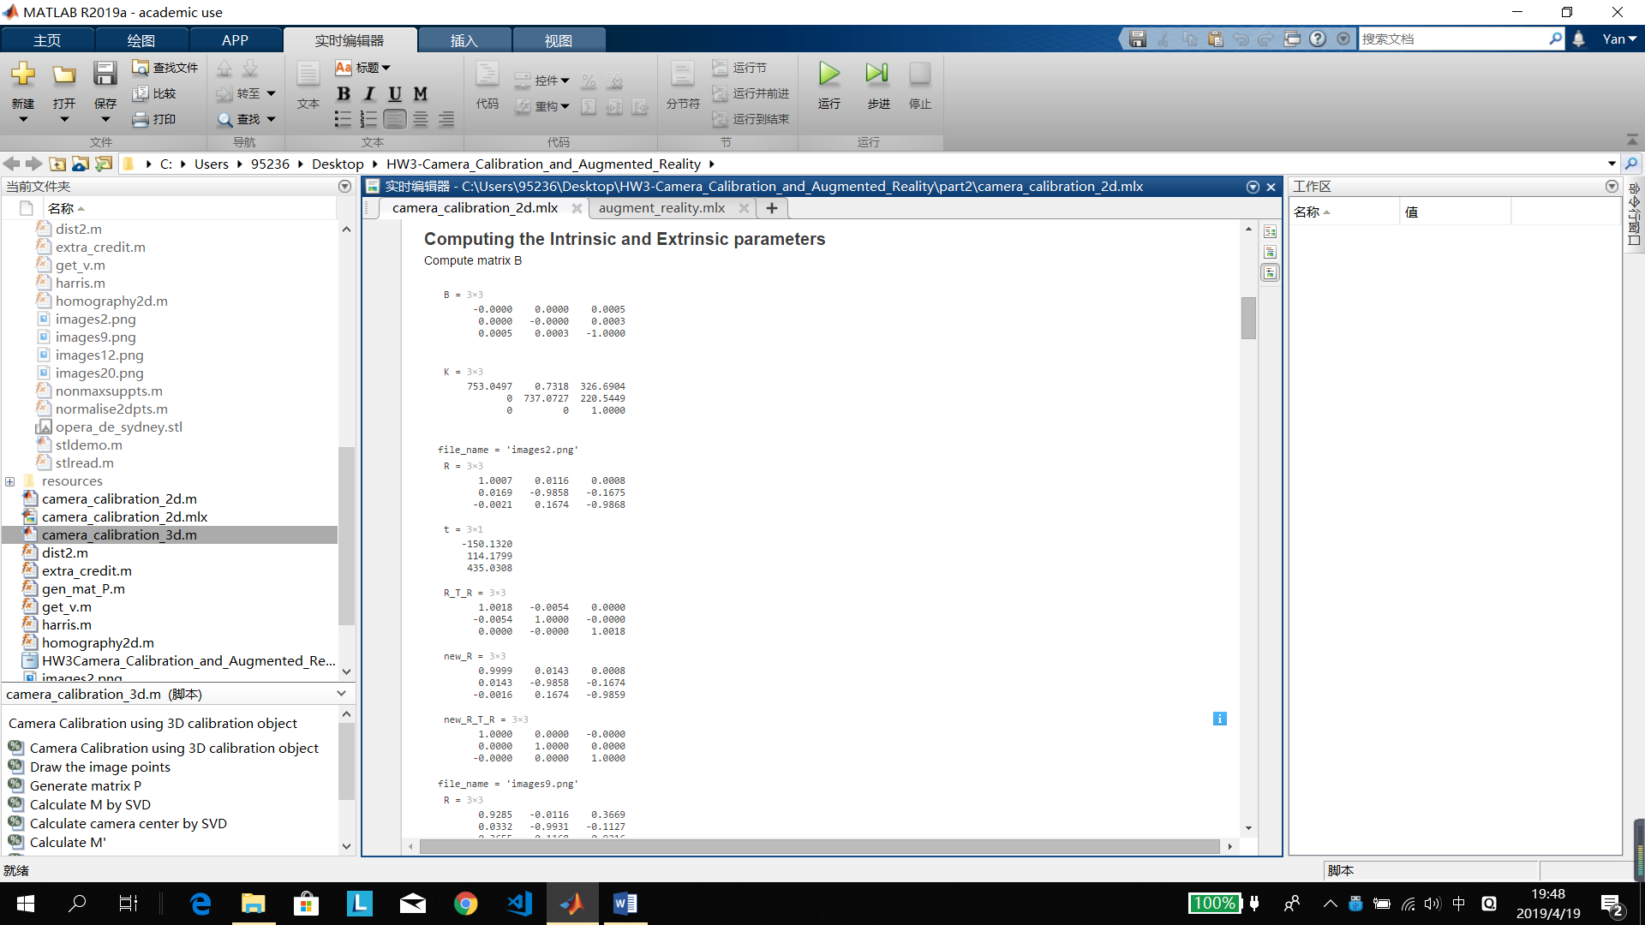

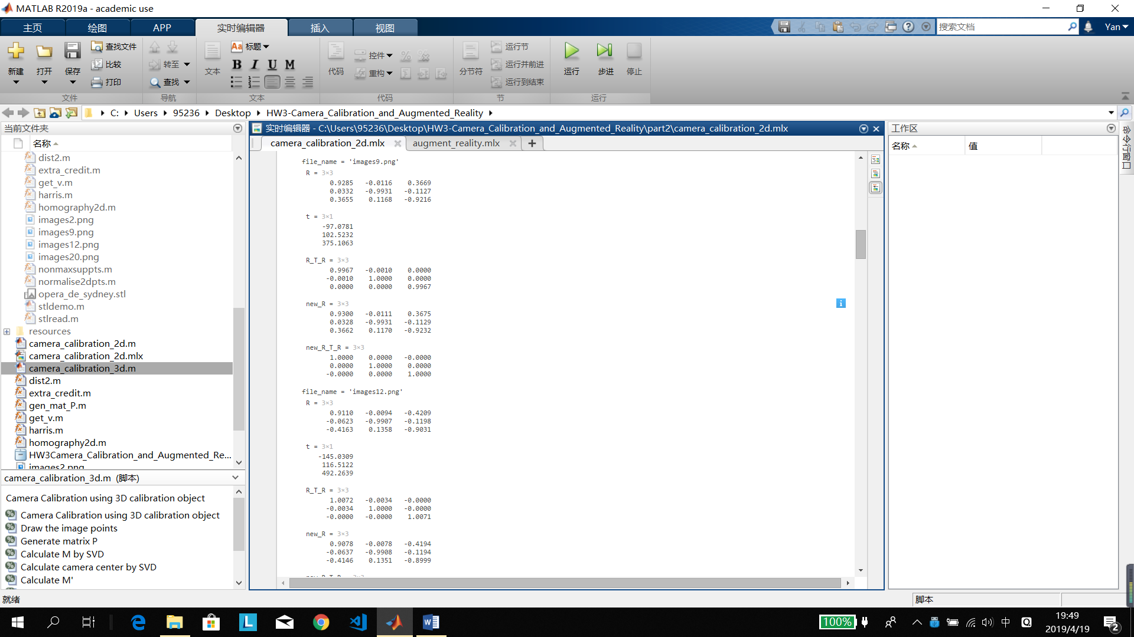

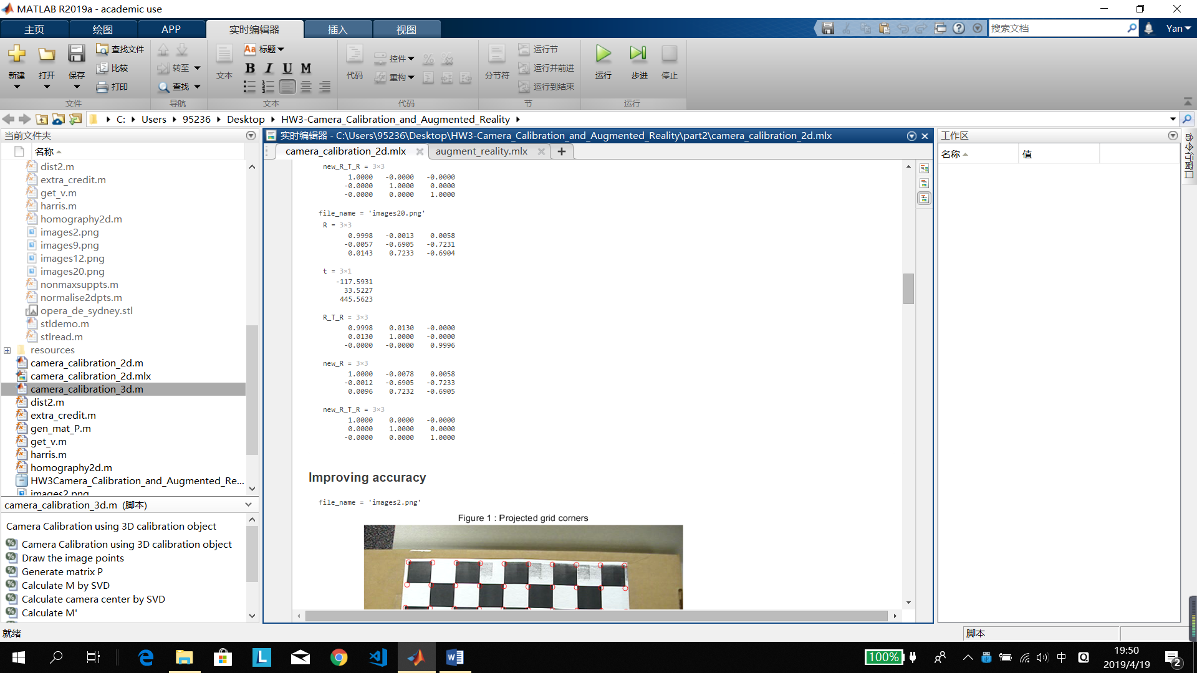

## Improving accuracy

The figure 1 is painted using red circle, figure 2 is painted using yellow rhombus and figure 3 is painted using pinkish red cross.

The results are:

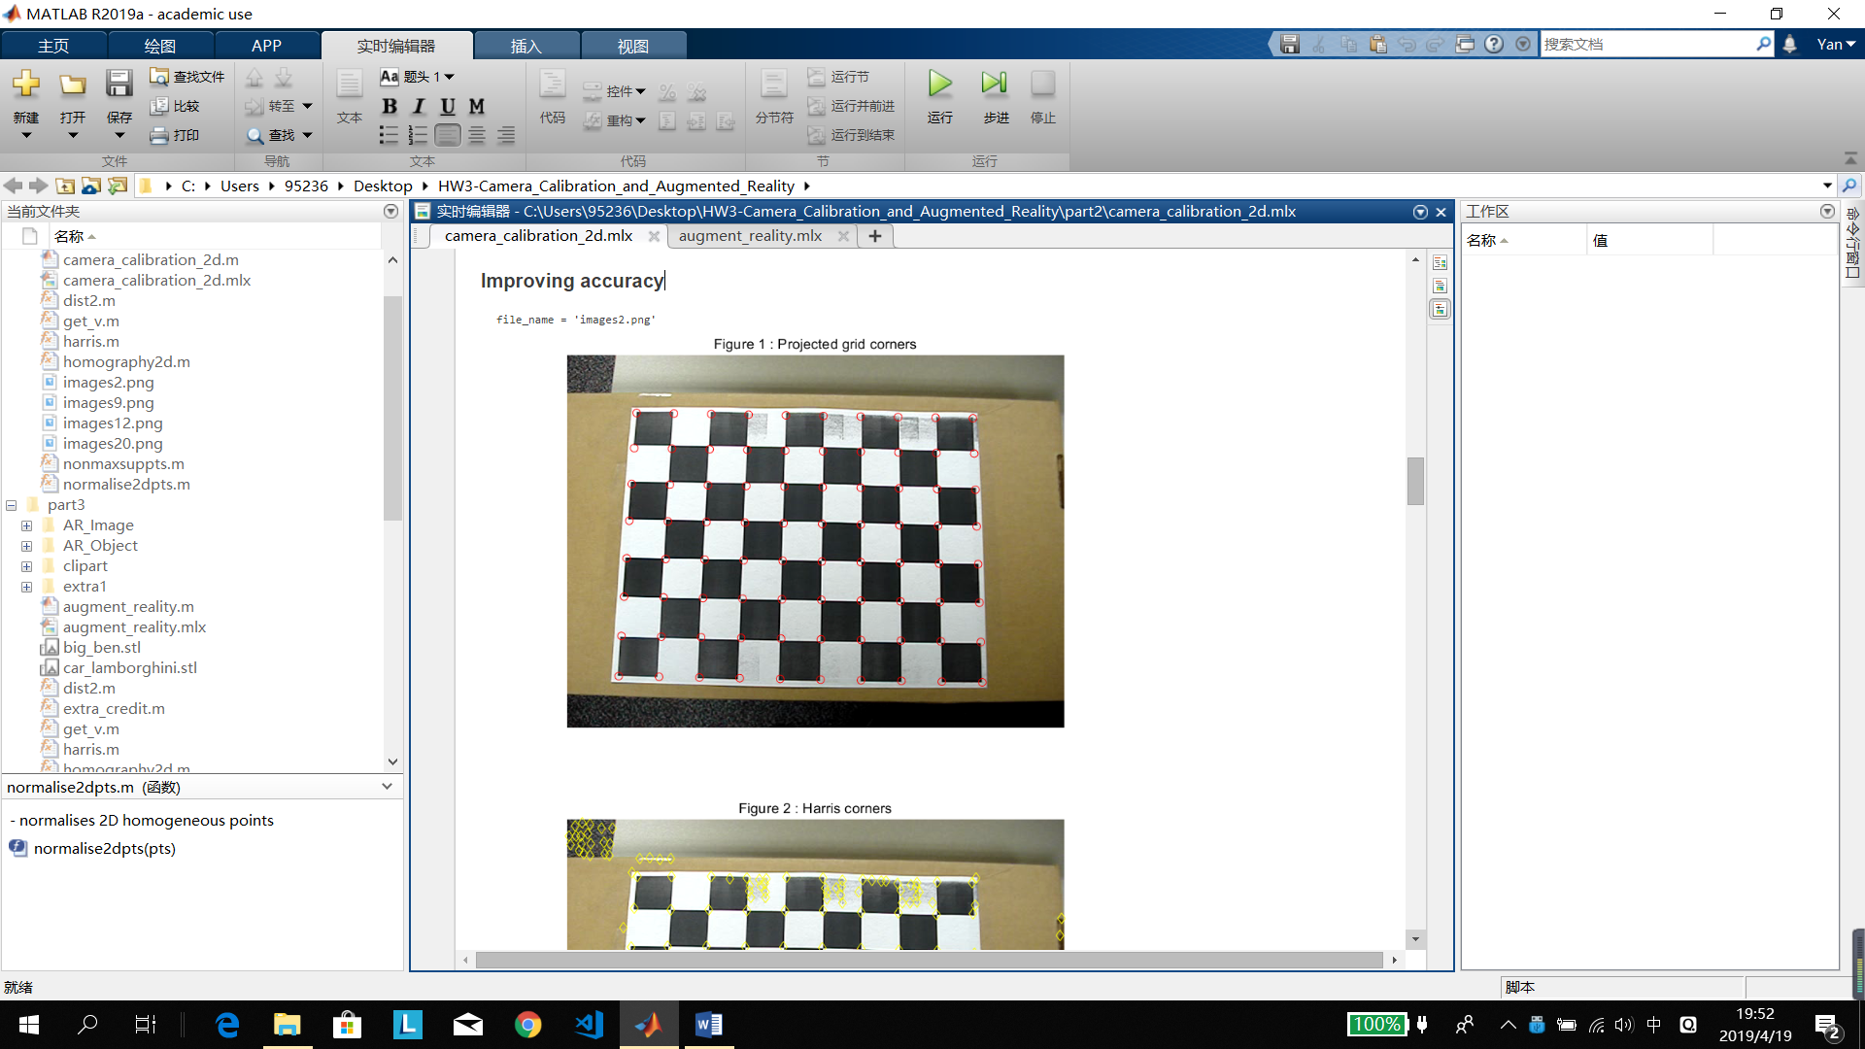

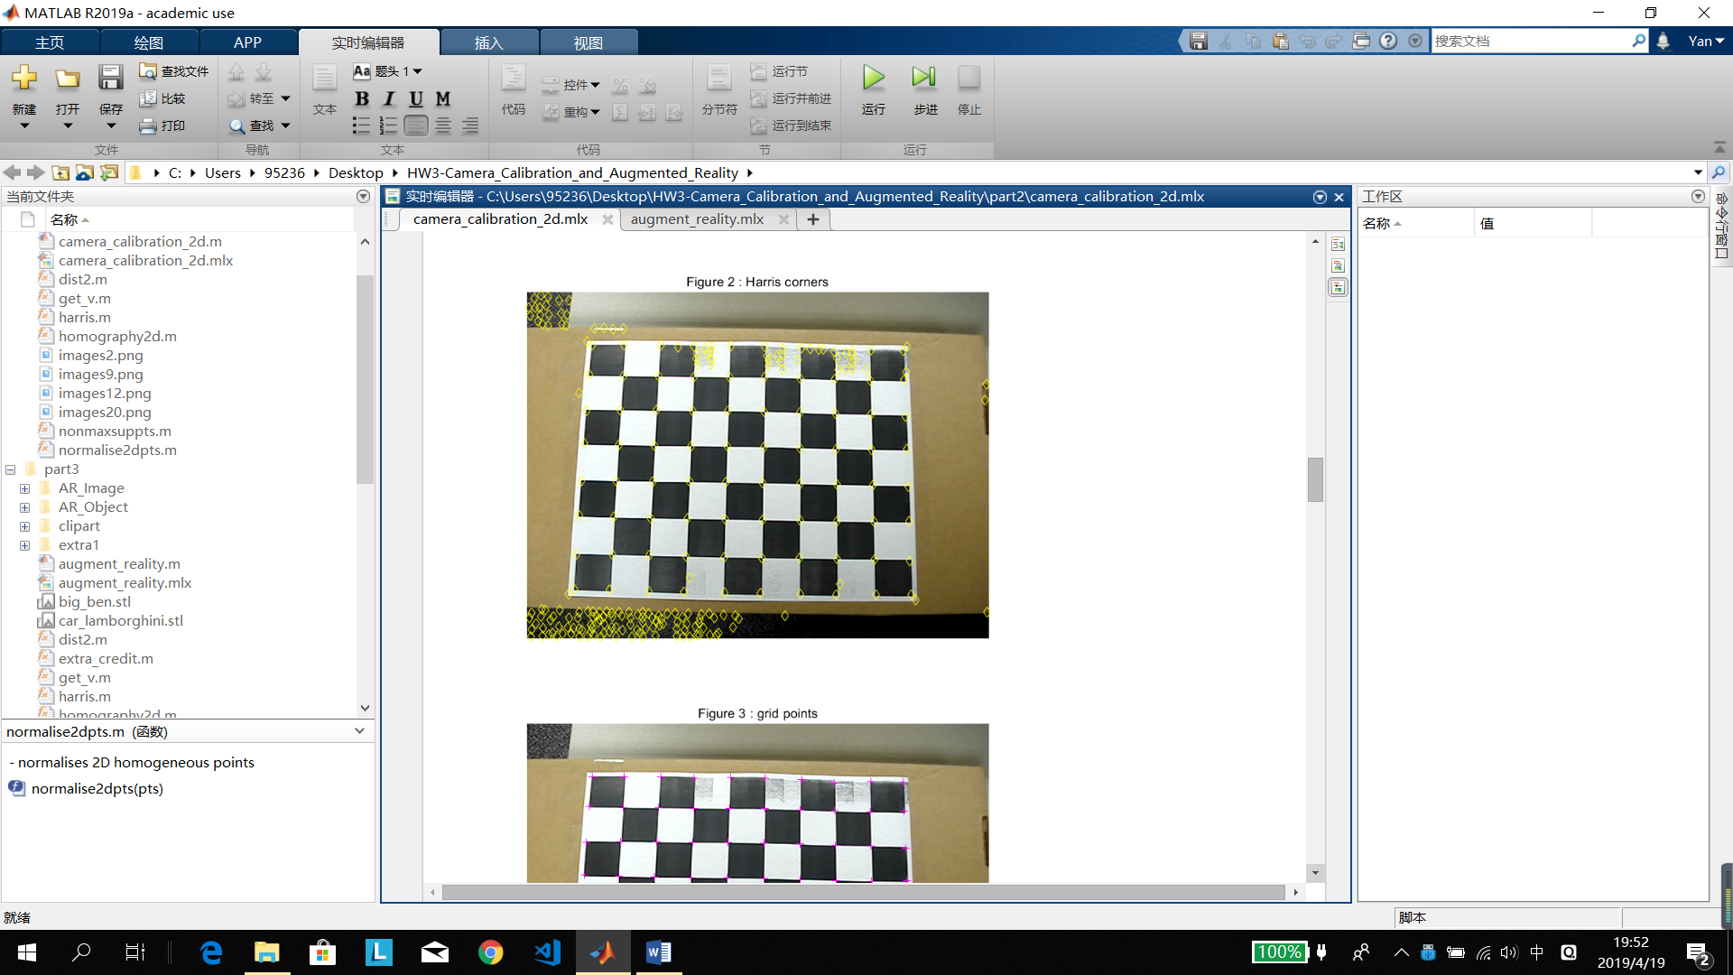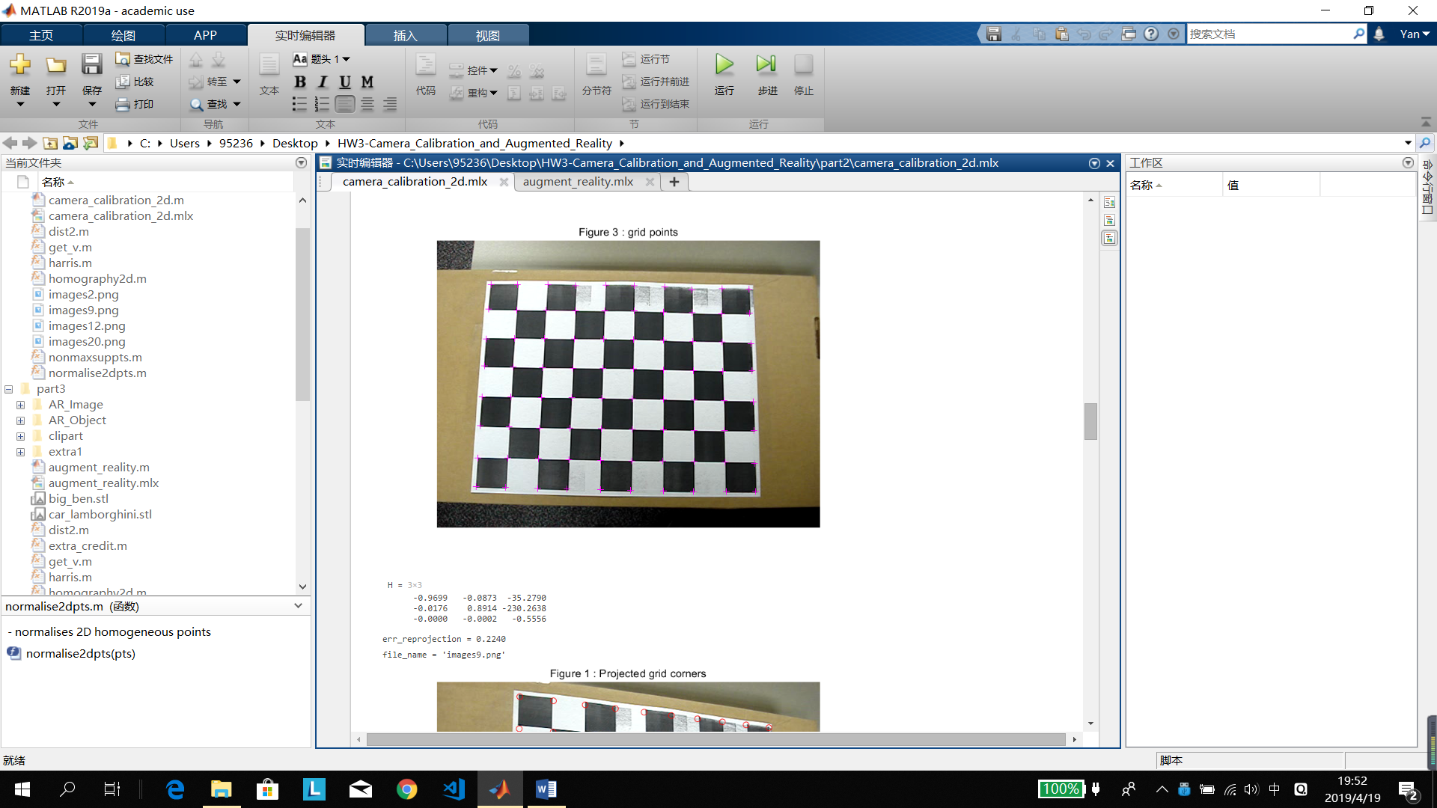

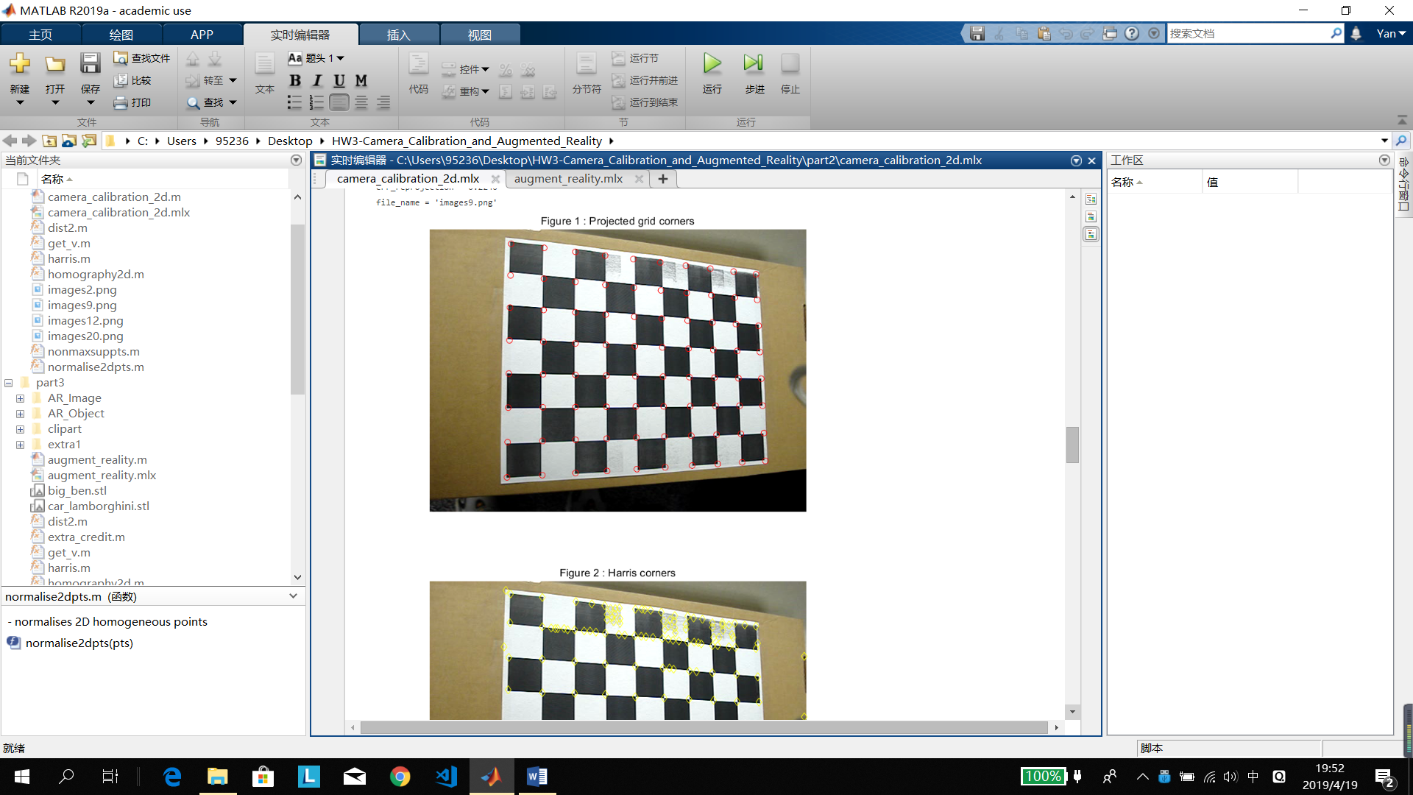

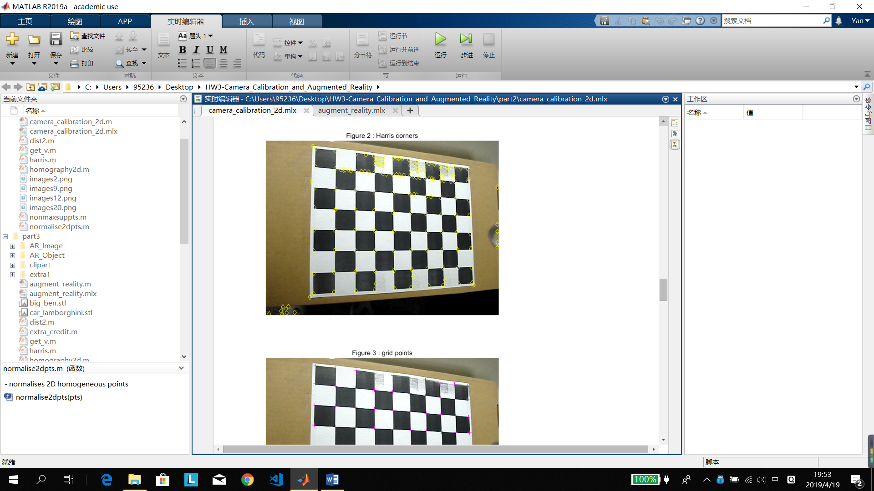

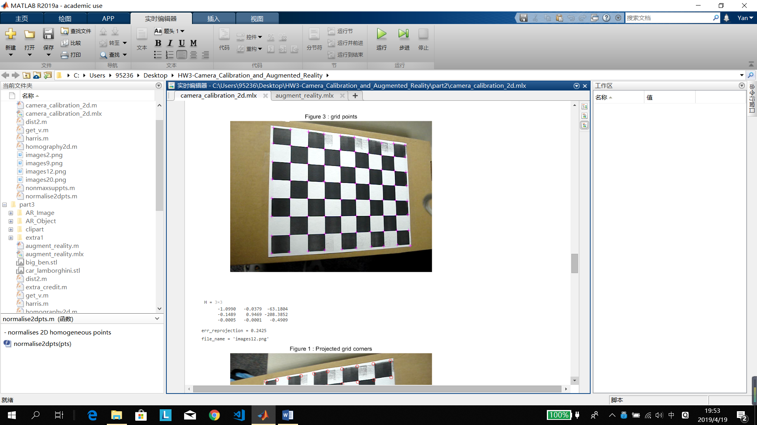

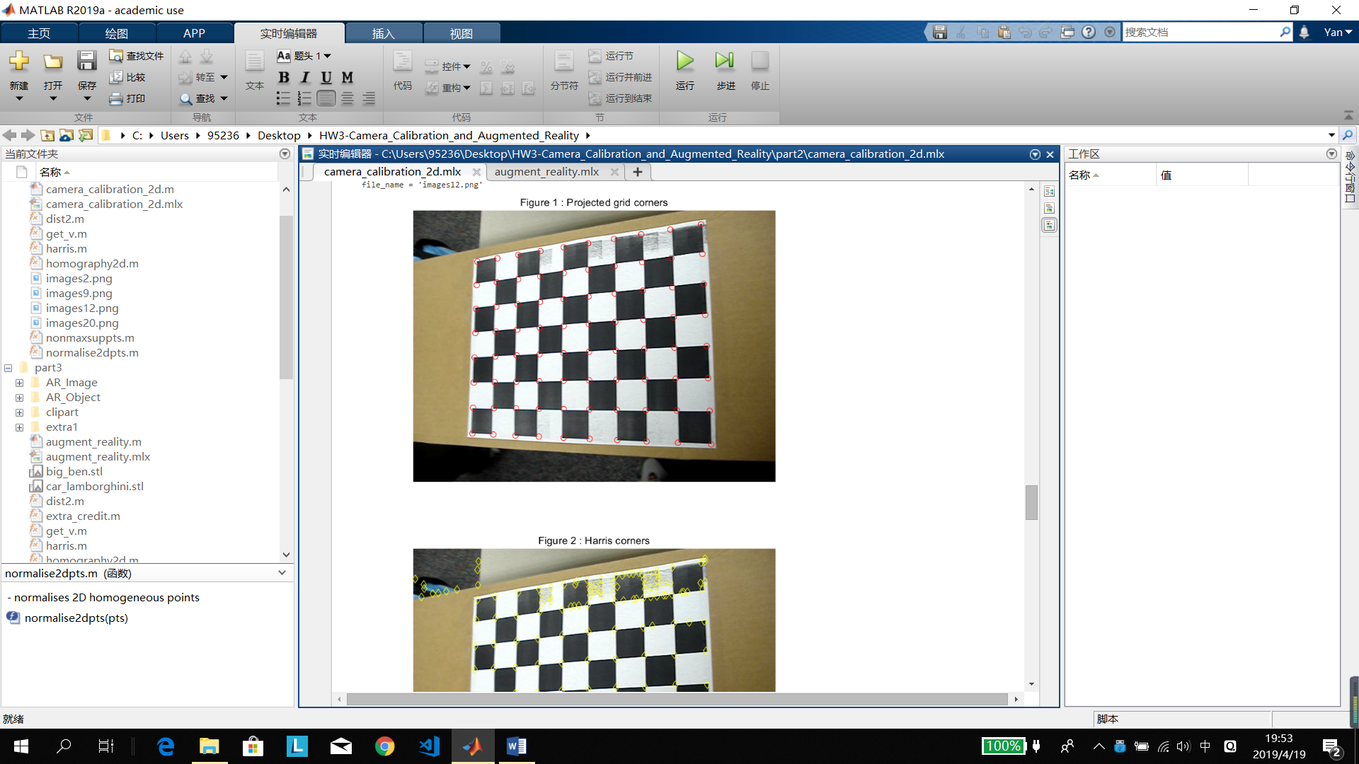

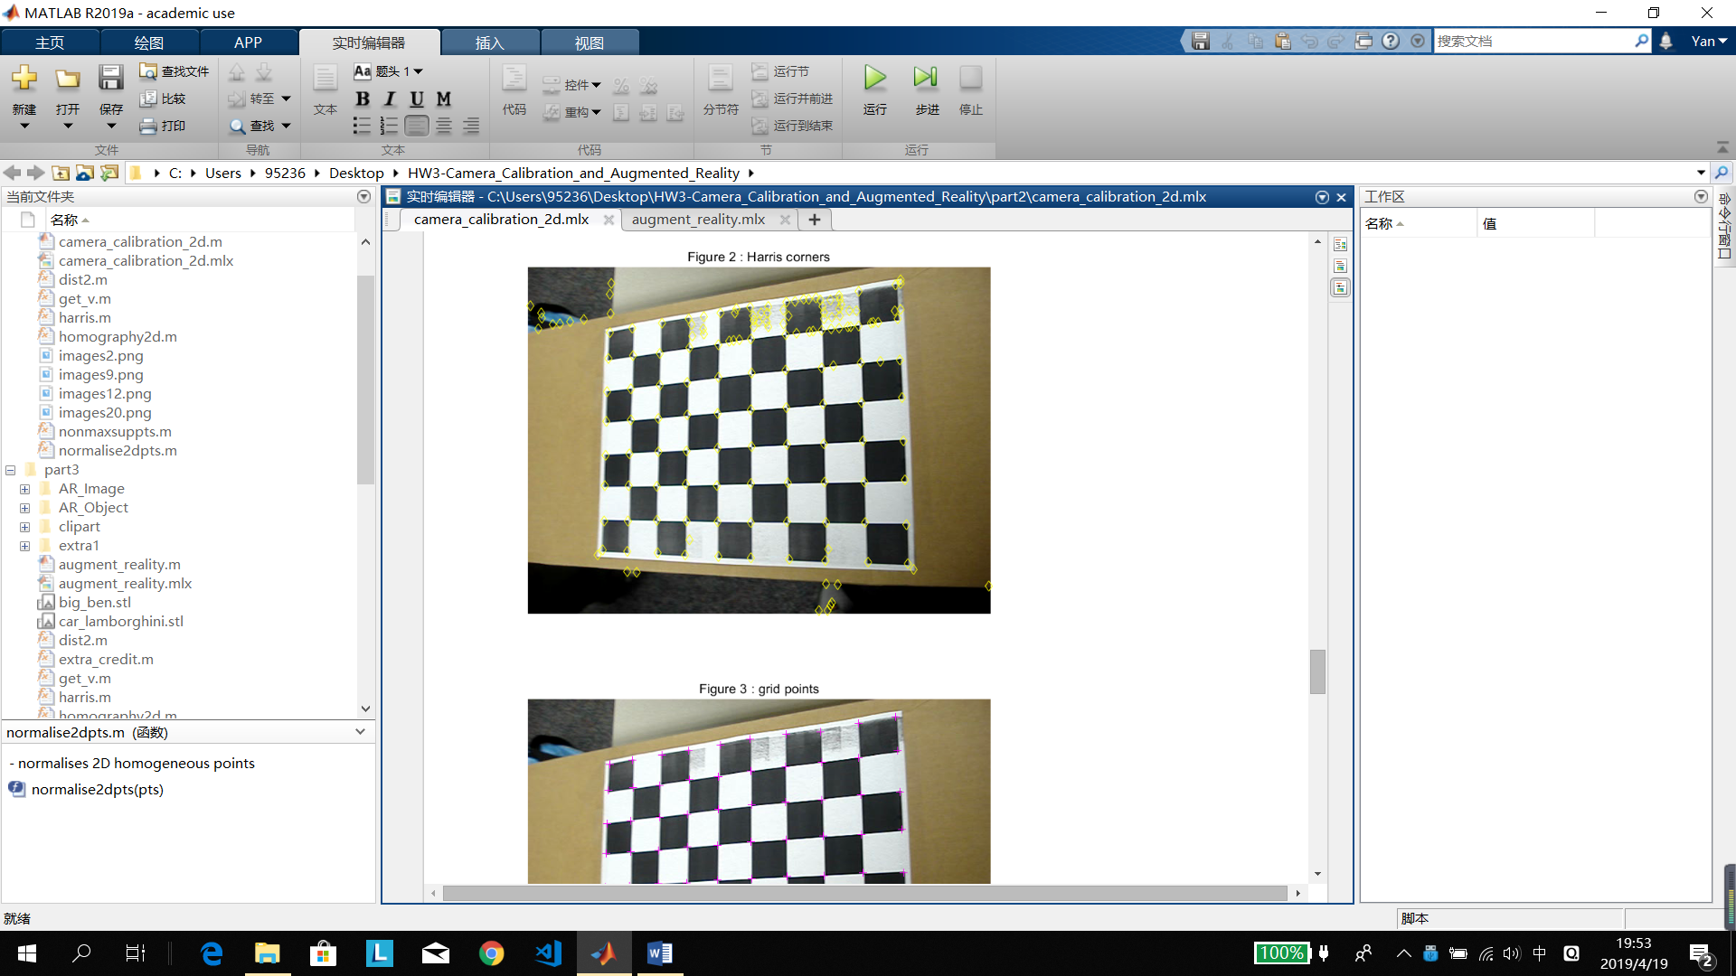

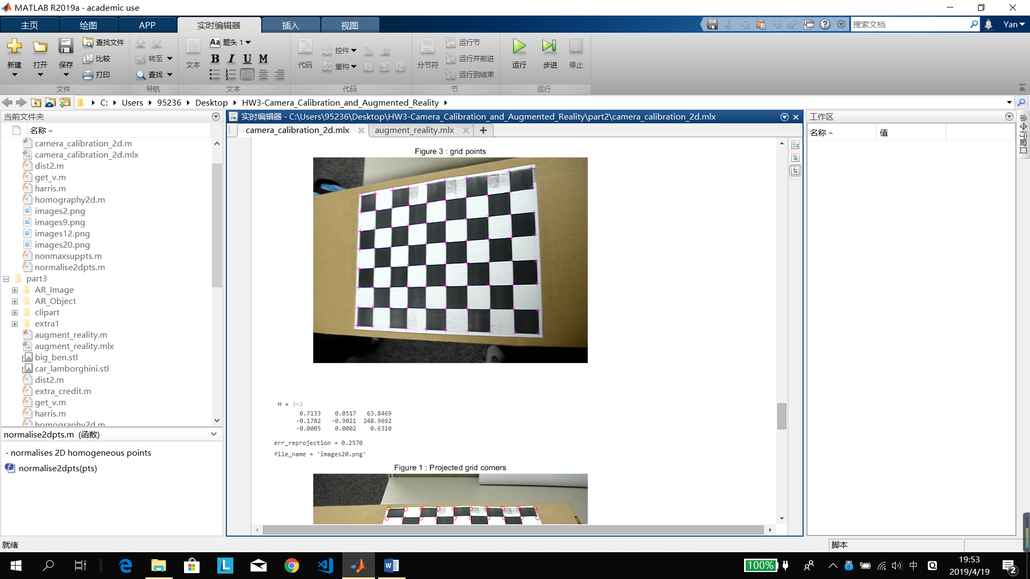

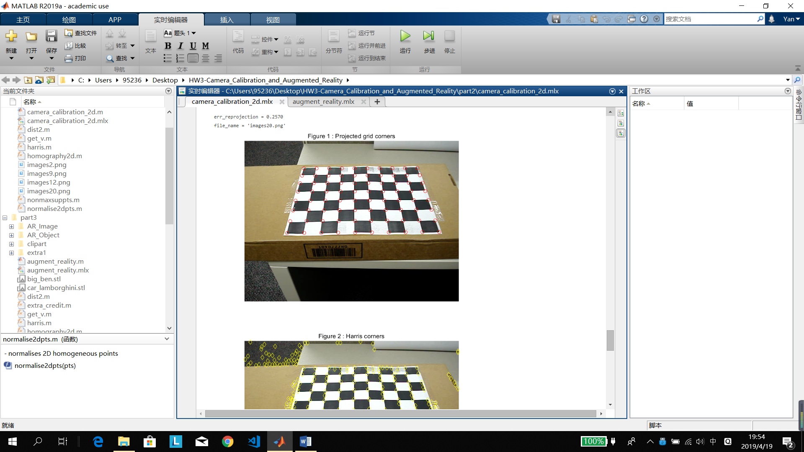

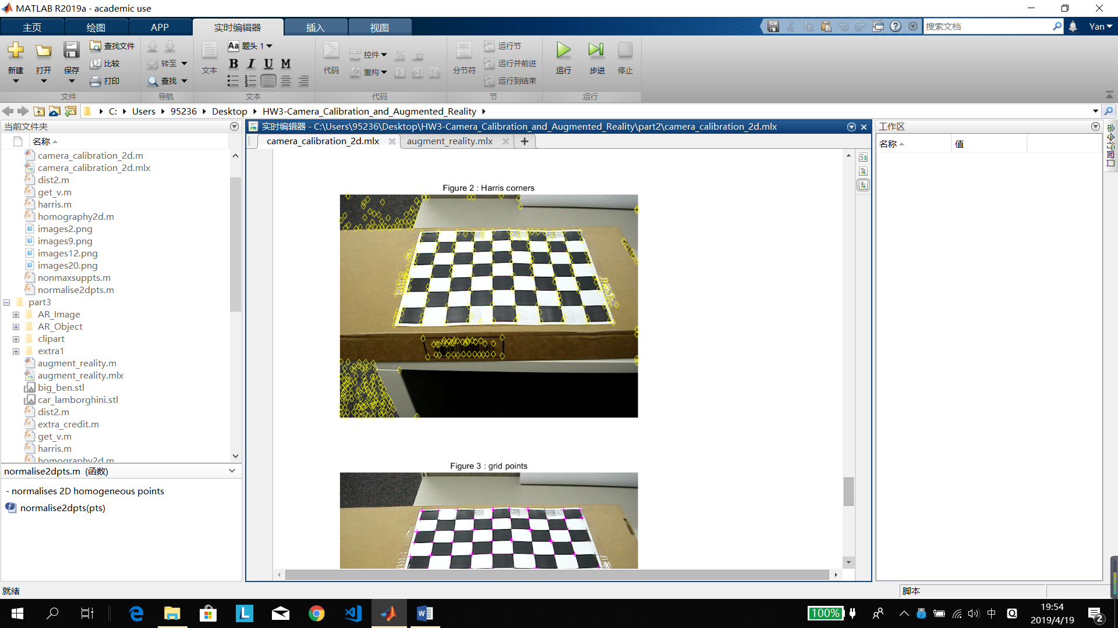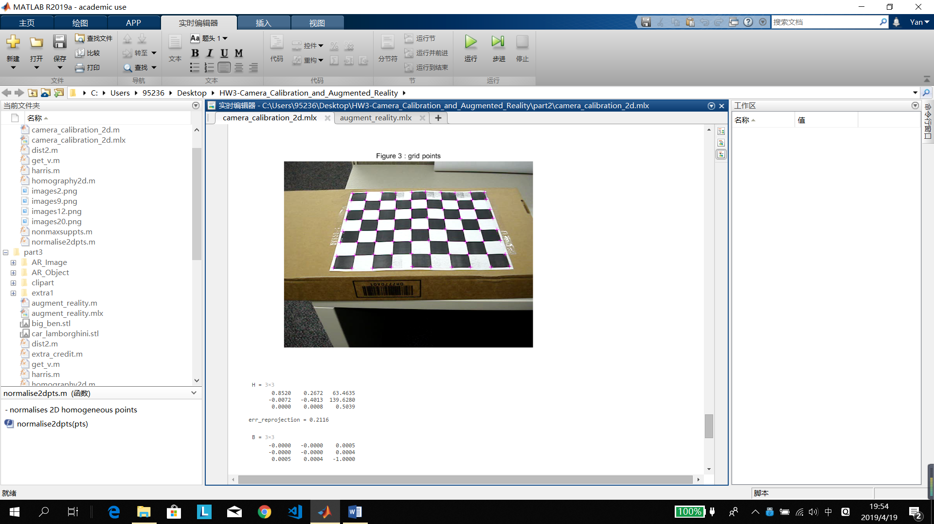

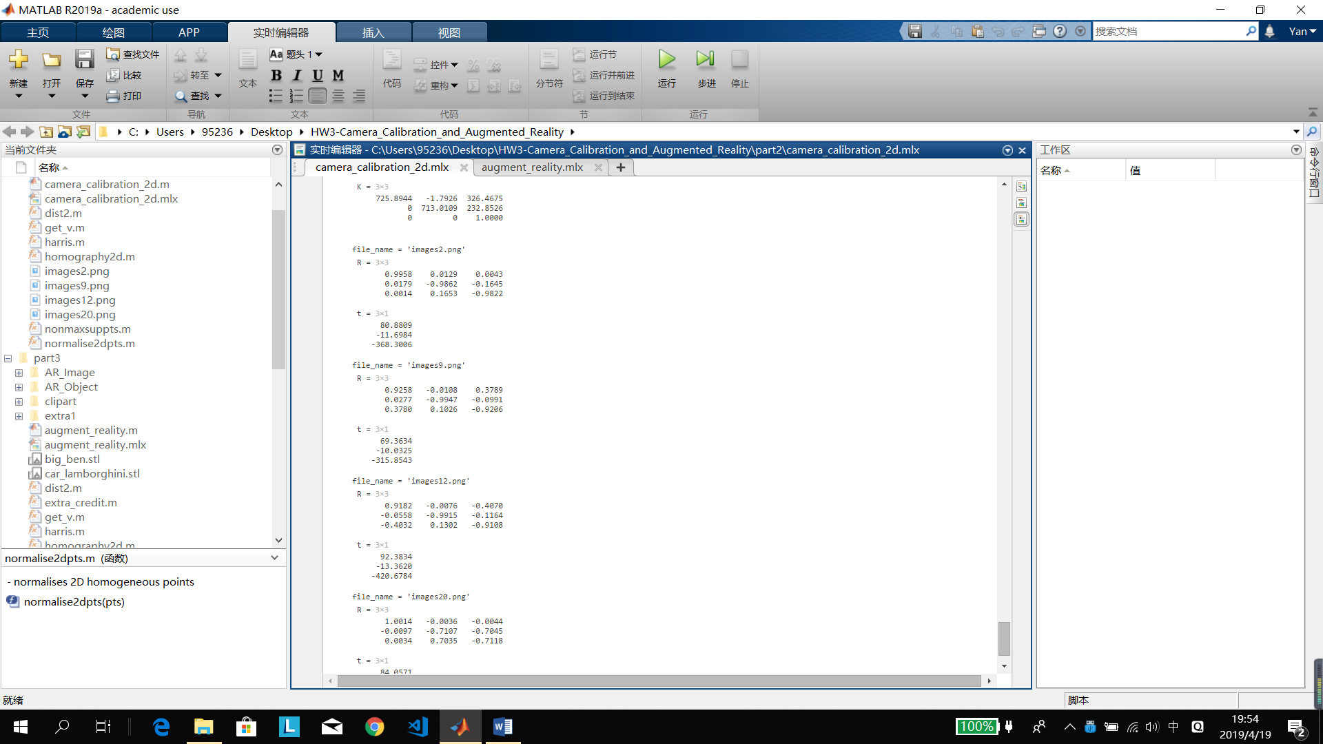

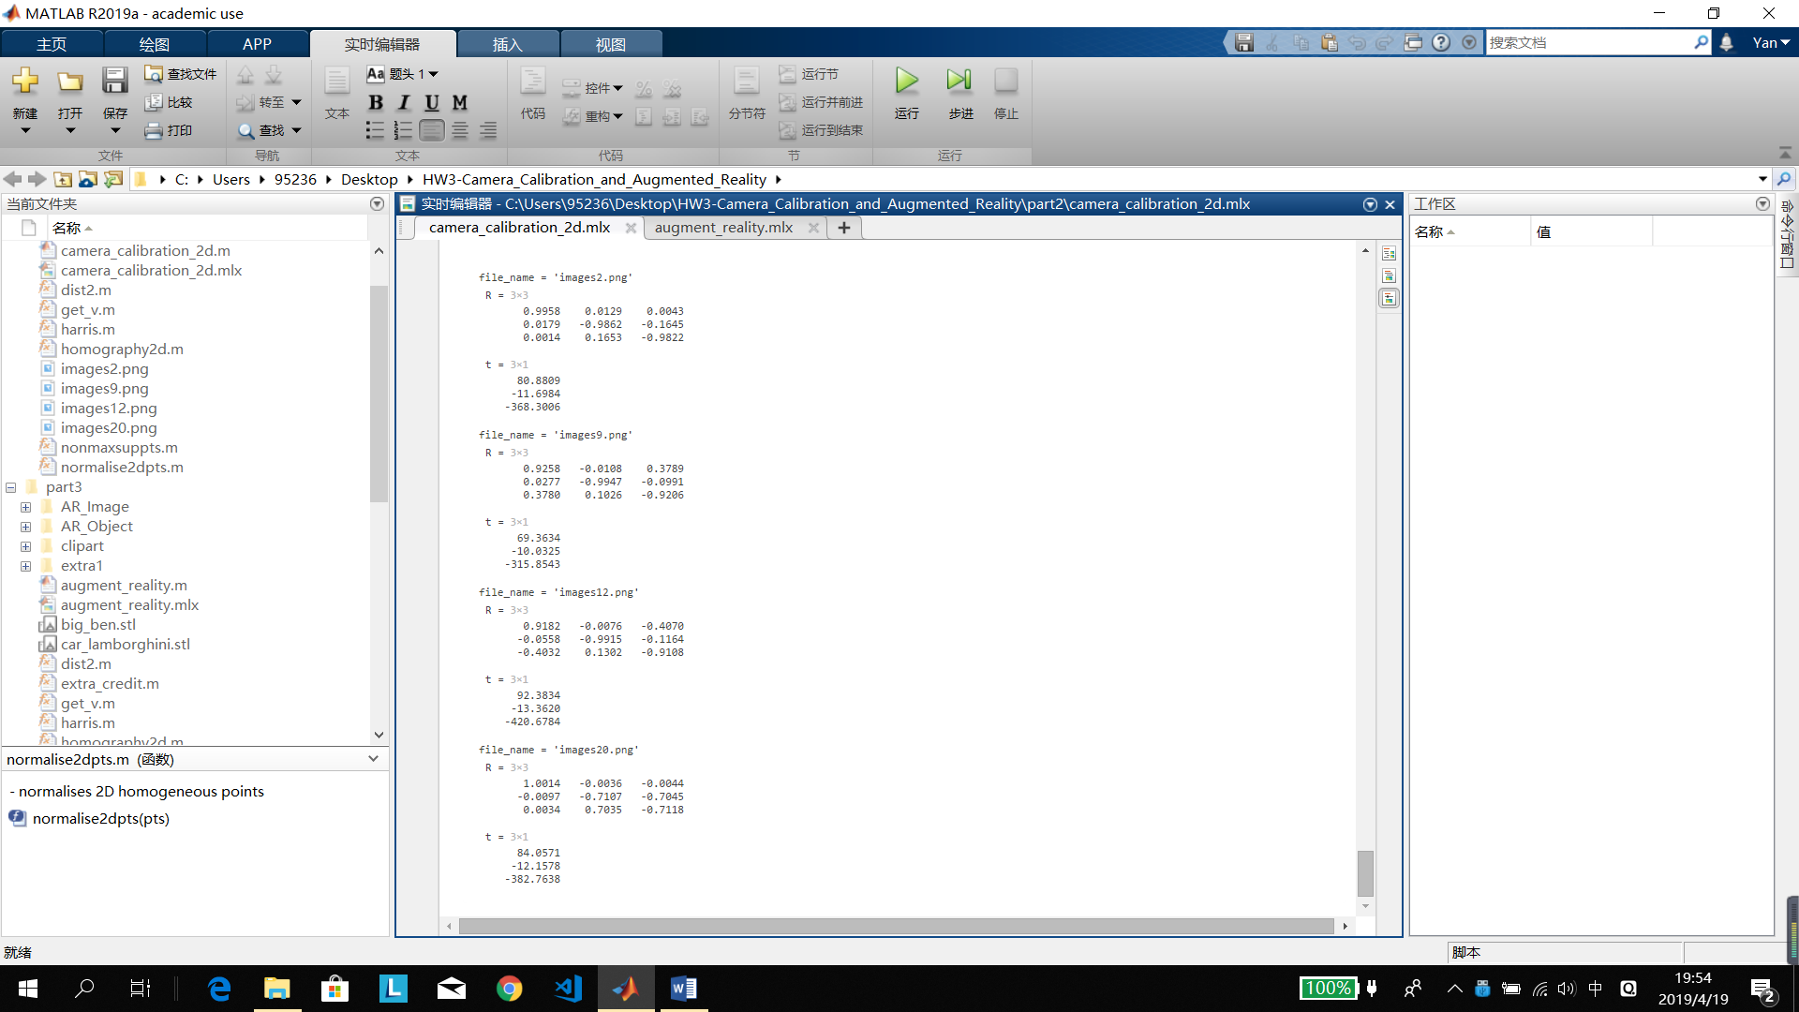

## Can you suggest a way this can be done automatically (i.e without first letting the user manually select the 4 corners)?

From Harris Corner detector, we can get many corners including the ones we really want. First the pixel of the corner we want is dark, it's filters out many times. And the measure of the grid is bigger than the noises. Second, we already know the distance of these 4 points. Although the image is distorted, we can get use an approximate distance. Then we can use this approximate of grid distance to find the proper grid corners. From these grid corners, we get the four outward corners as the corner we want.

# Part III: Augmented Reality 101

## Augmenting an Image

Because last 4 digits of my RUID is 1028, so I used picture 1.png

The results is in AR_Image.

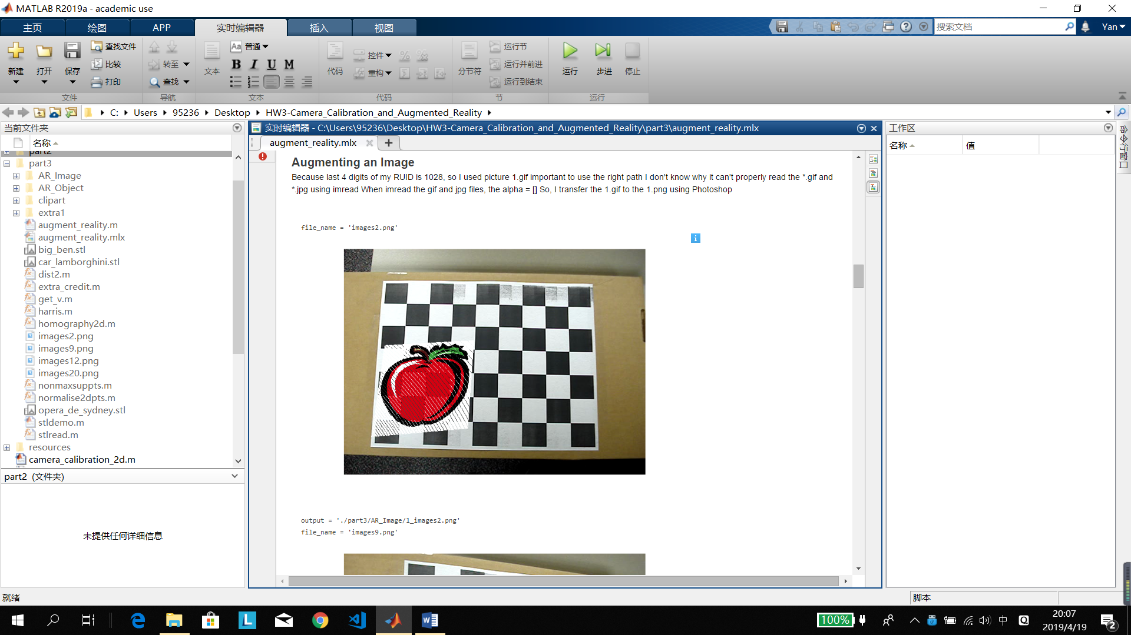

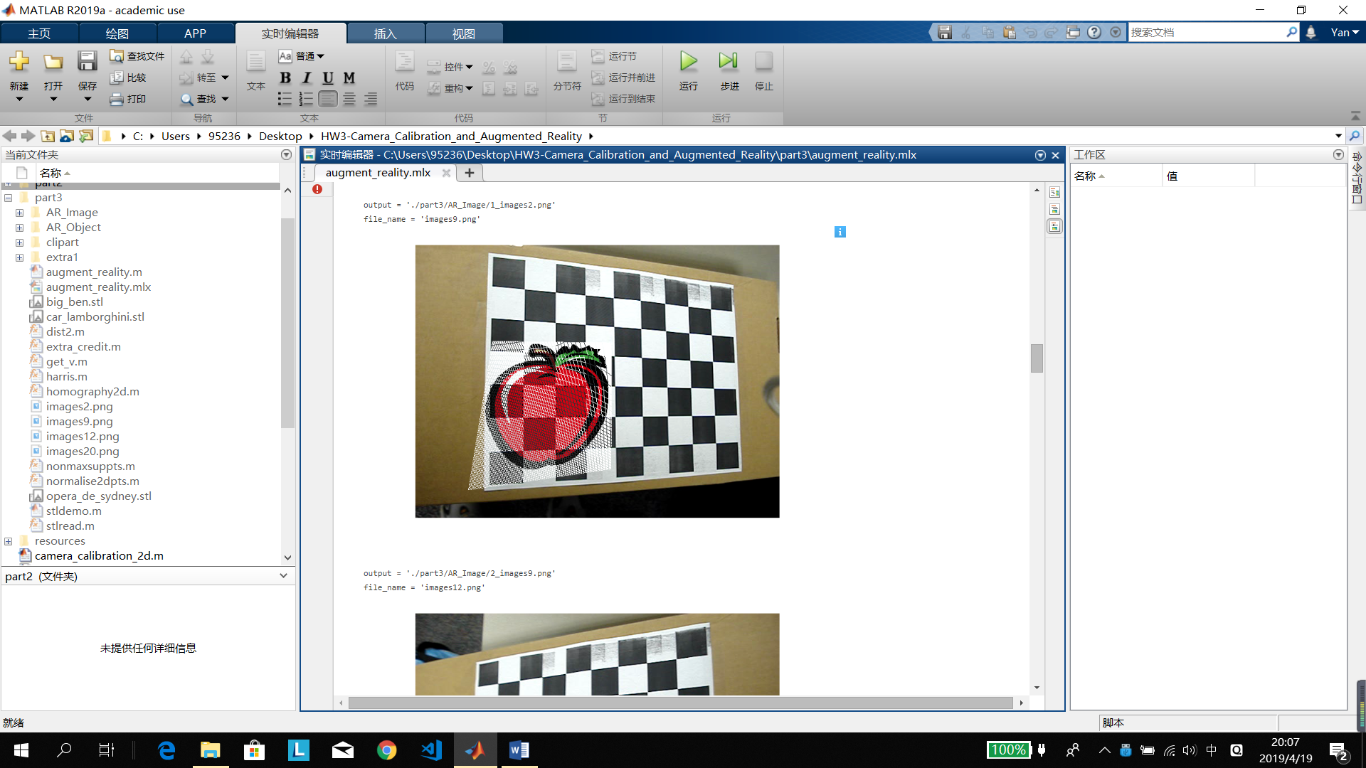

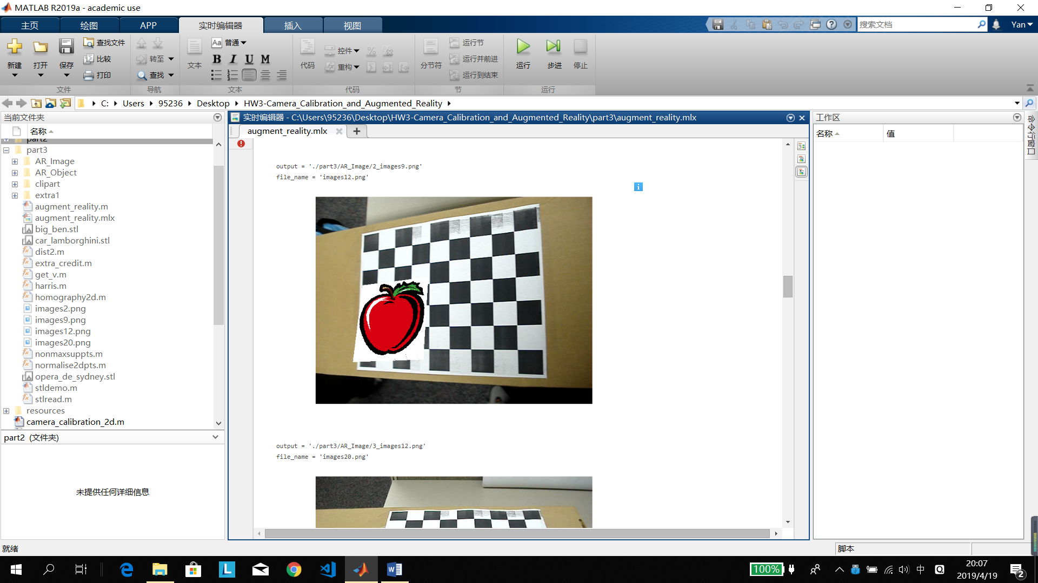

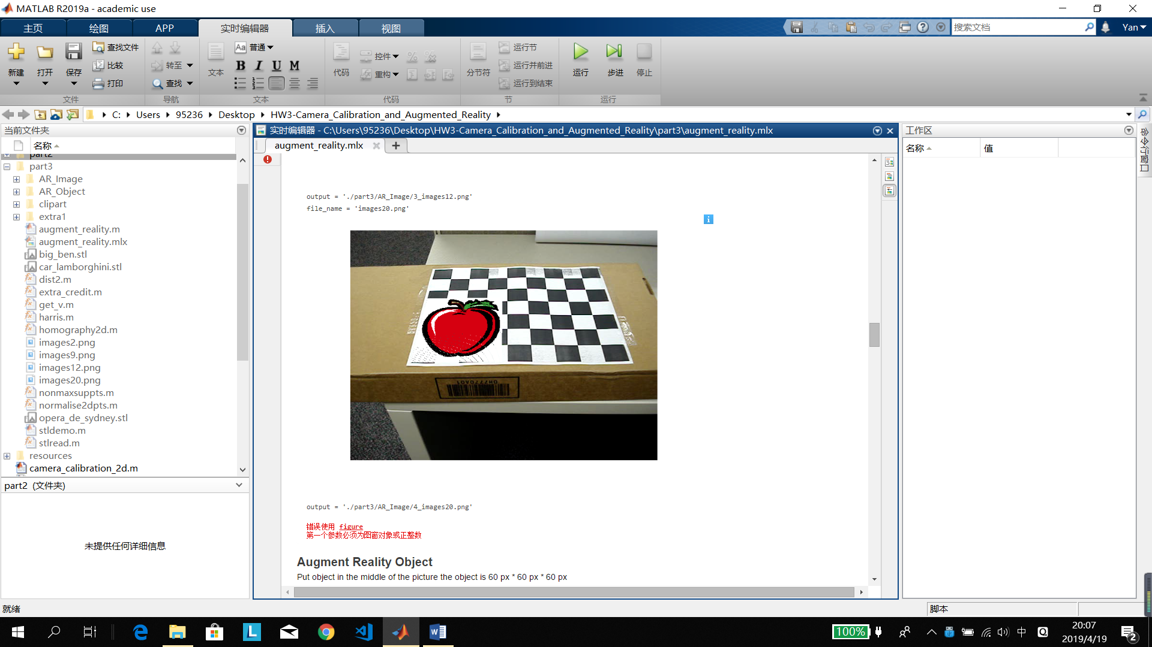

## Augmenting an Object

The results is in AR_Object.

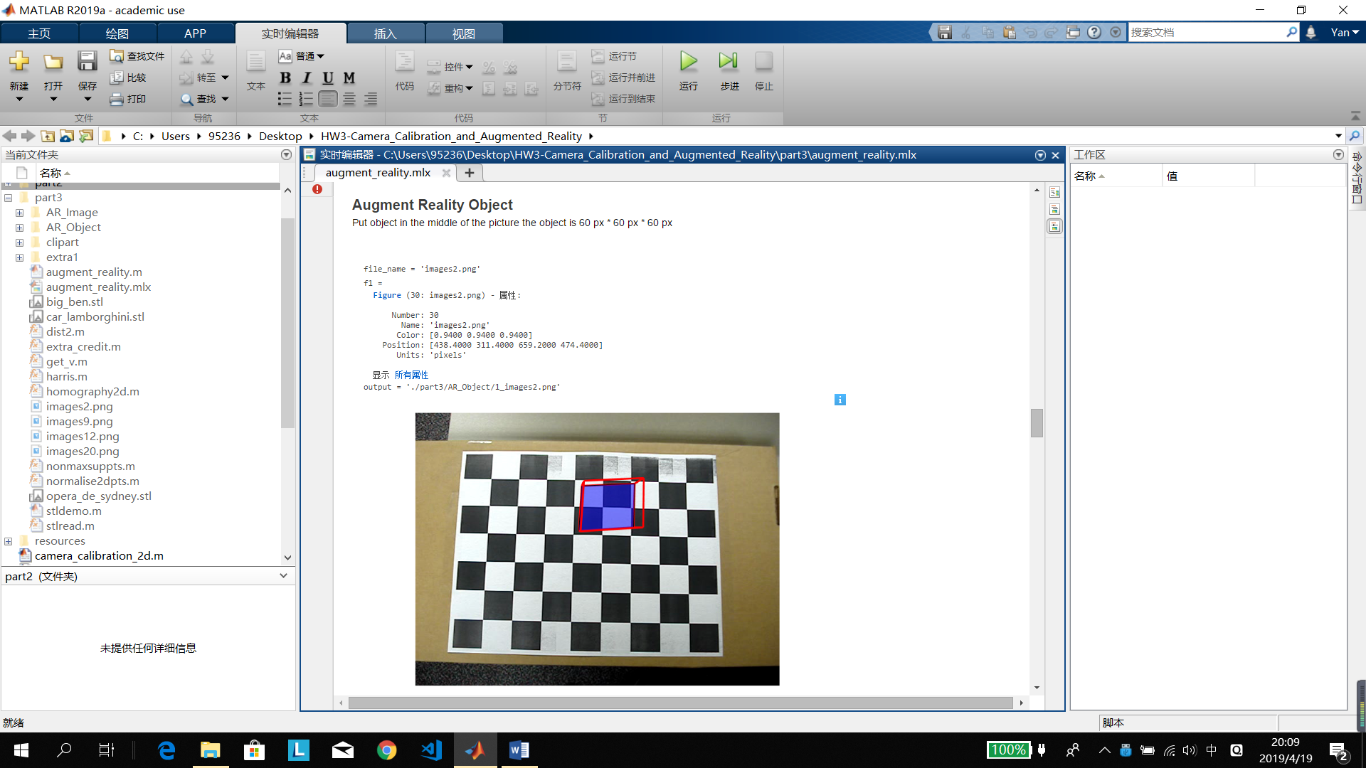

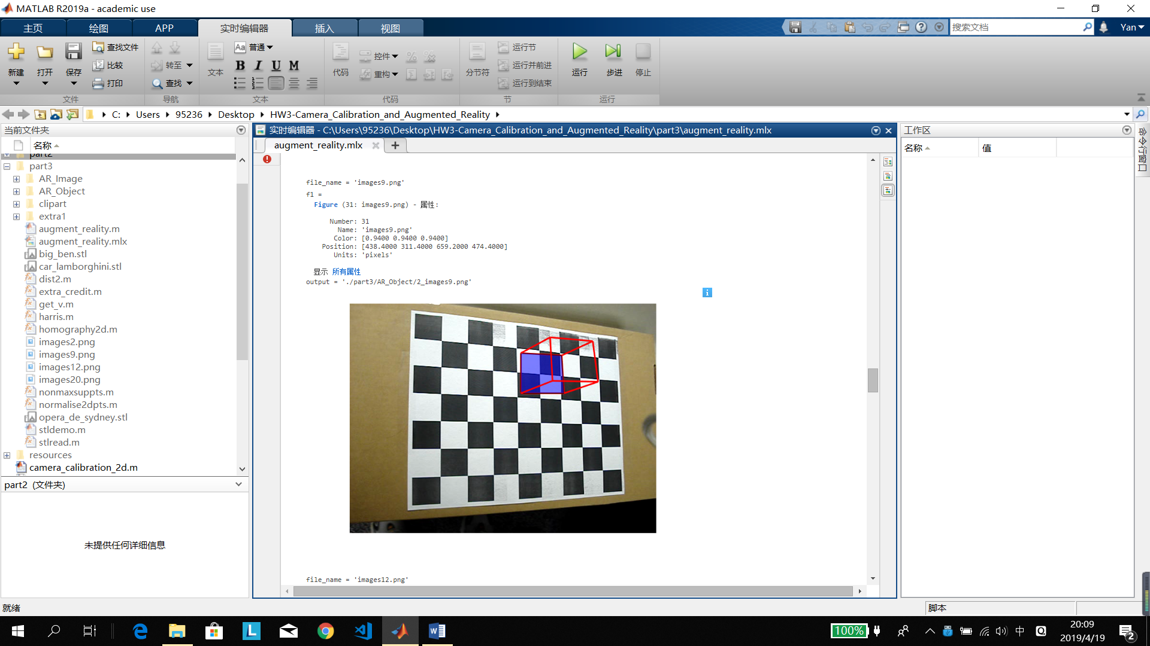

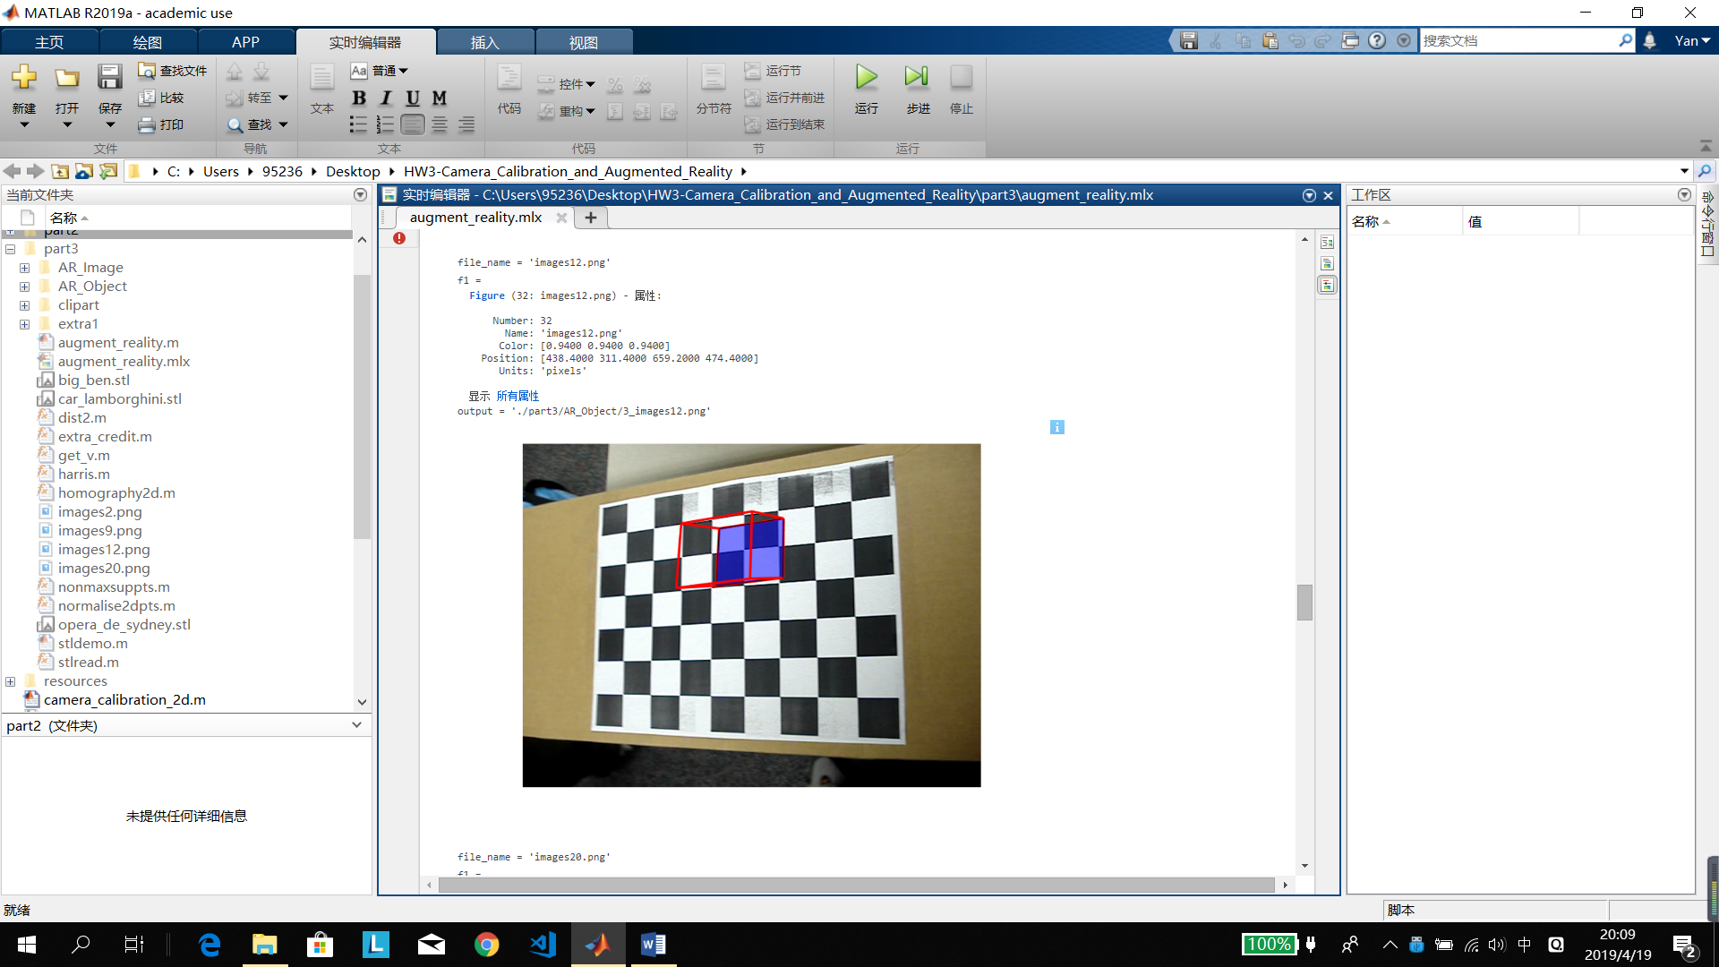

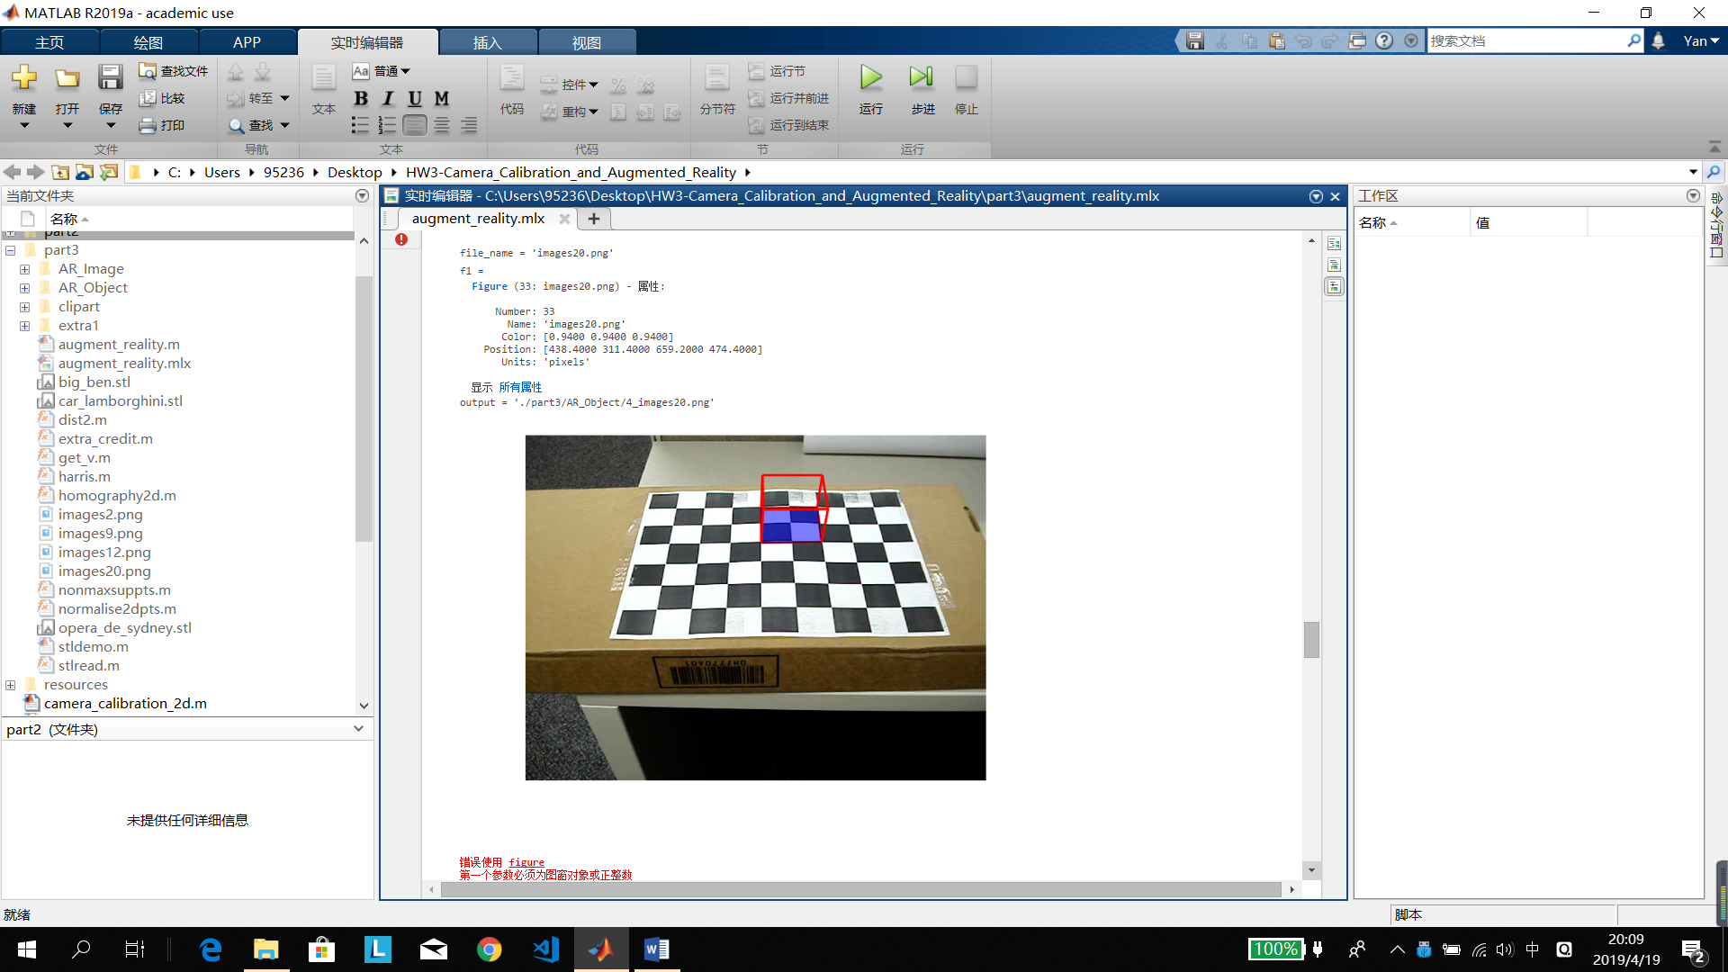

# Extra credit

## Instead of augmenting a cube, augment a general mesh from a 3D file of your choice.

I choose a Lamborghini model because it is clear to see the difference and I download a script stlread.m to read the 3 dimension coordinates from the 3D **stl** file.

When read a stl file, we can get face-vertex normal vectors and then we can change it to xyz coordinates. Refer to

<https://www.mathworks.com/help/matlab/ref/patch.html?searchHighlight=patch&s_tid=doc_srchtitle#burynyu-8>

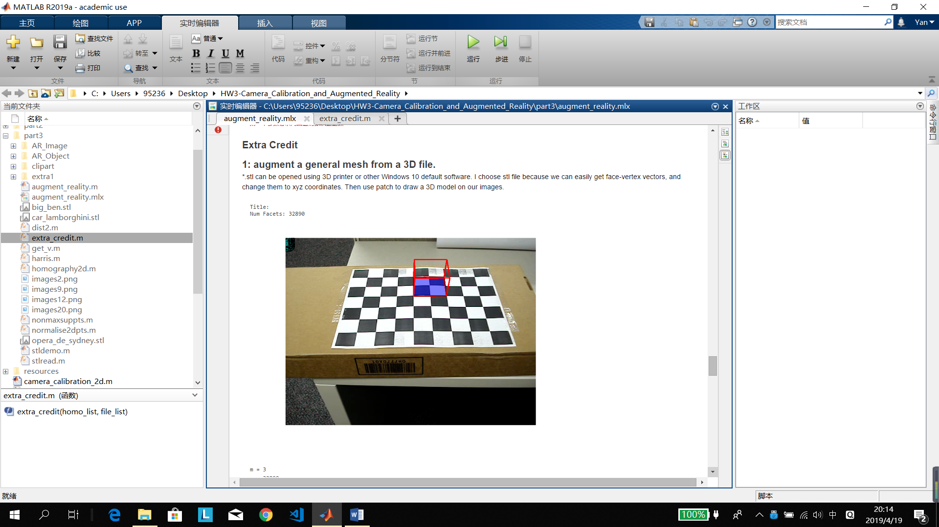

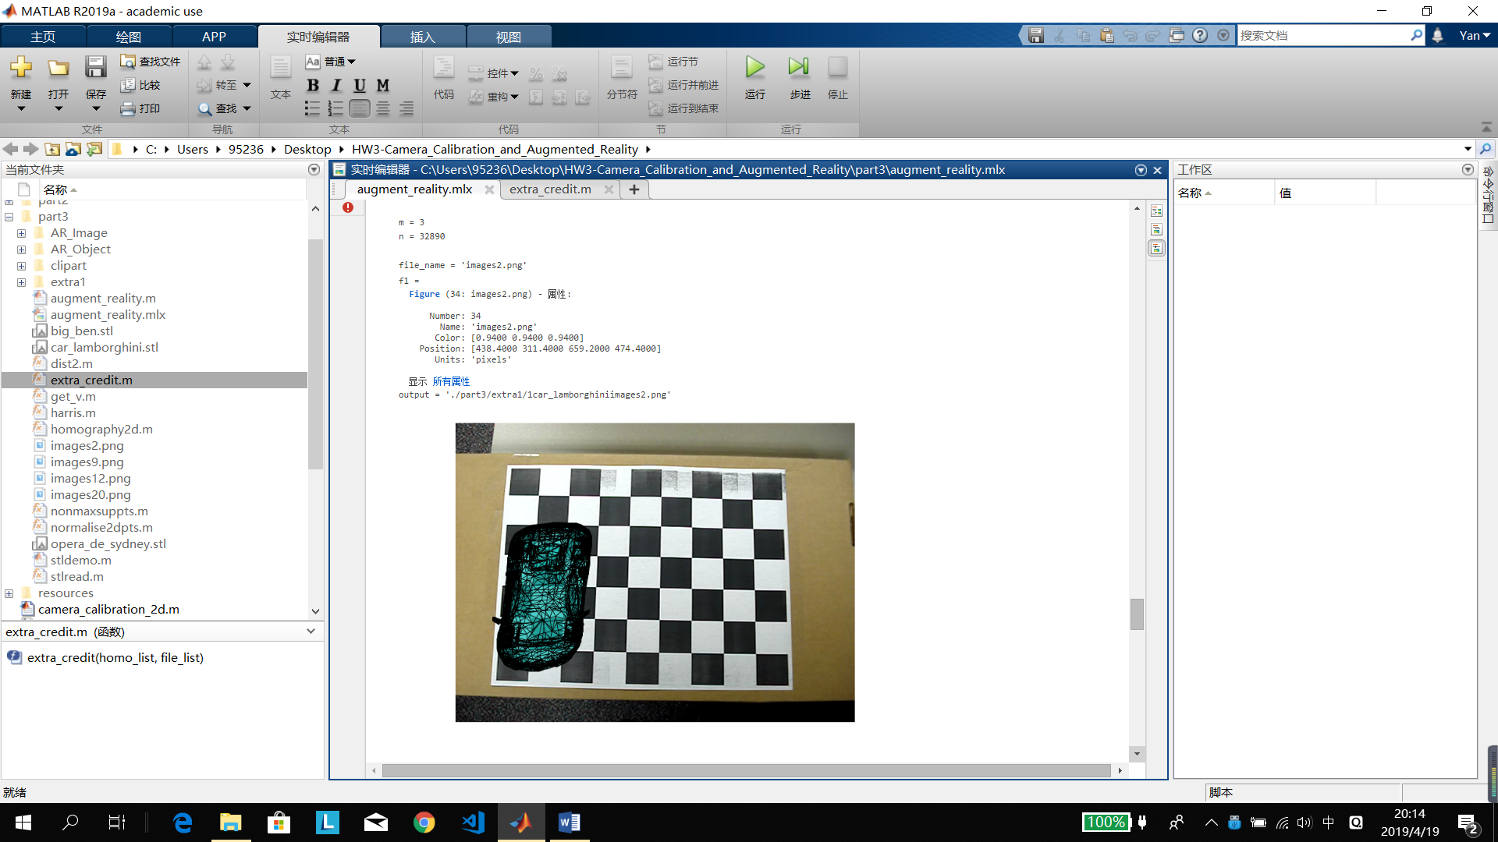

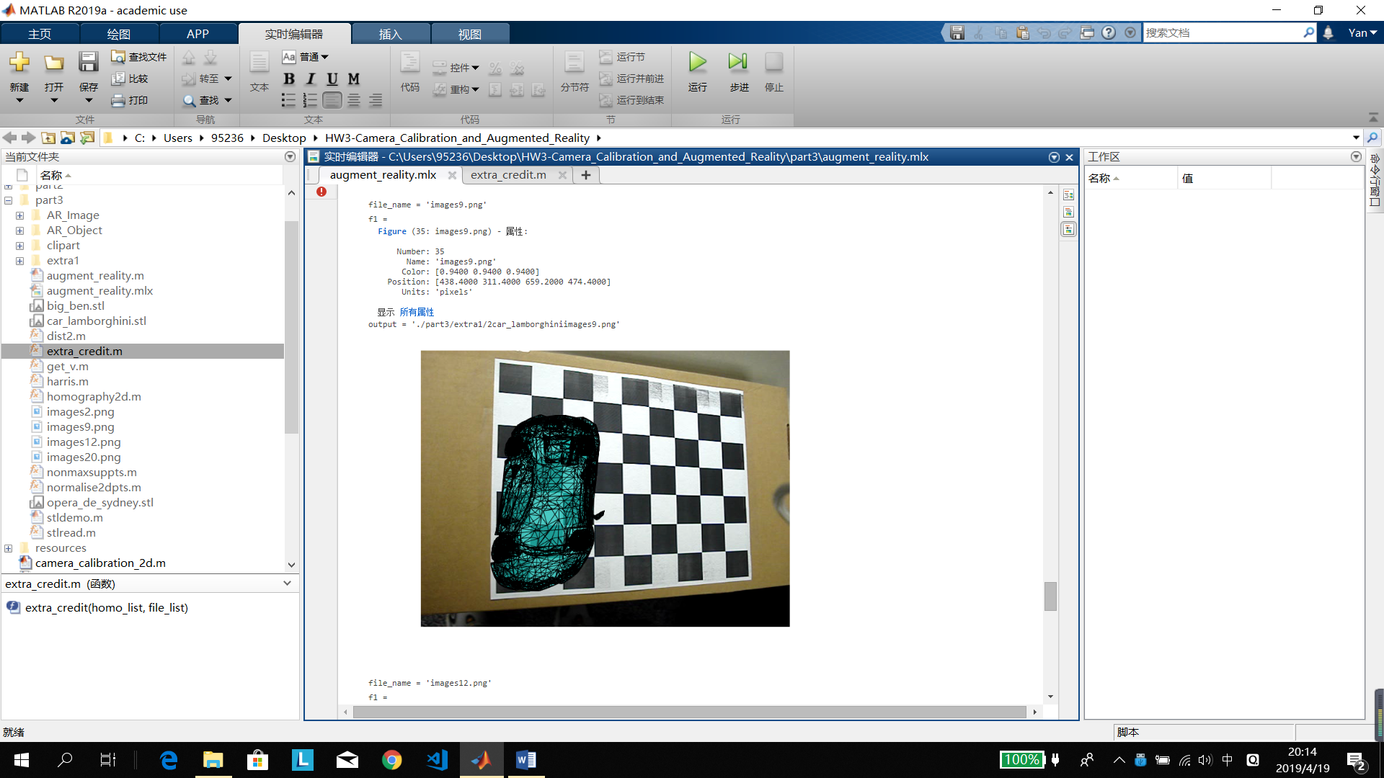

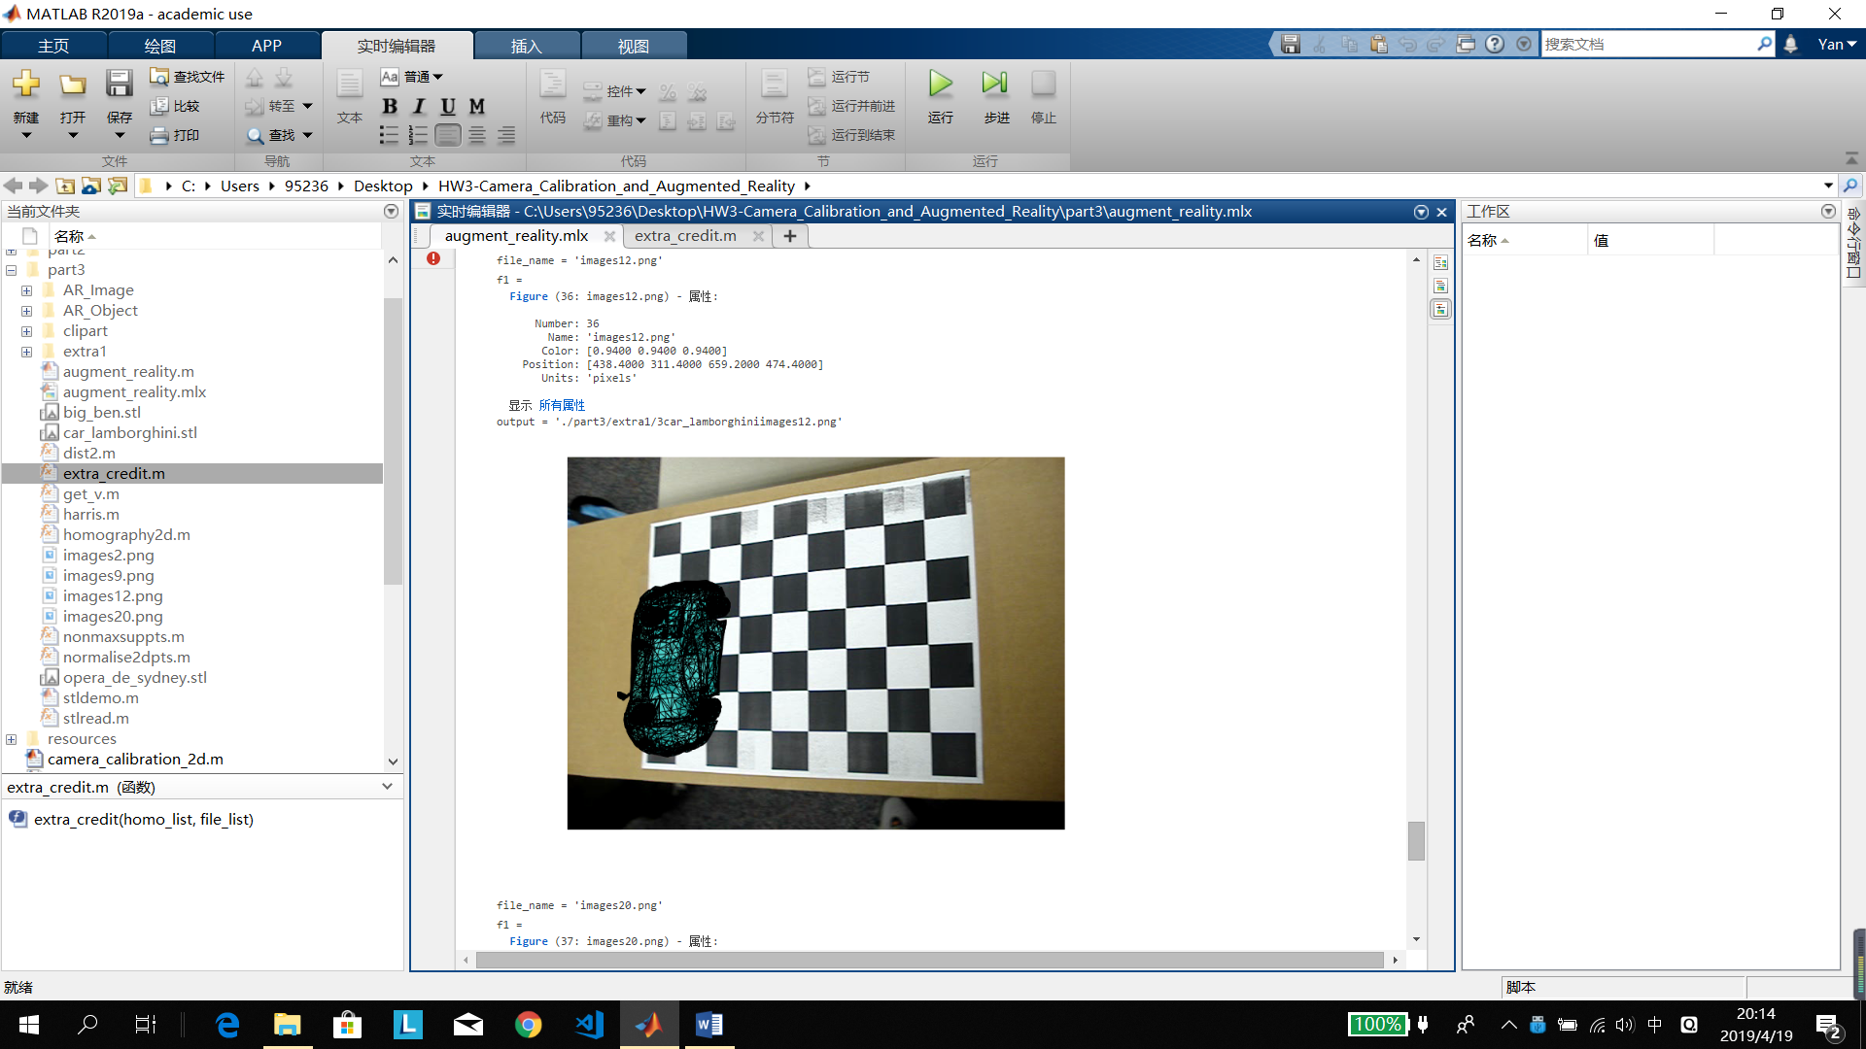

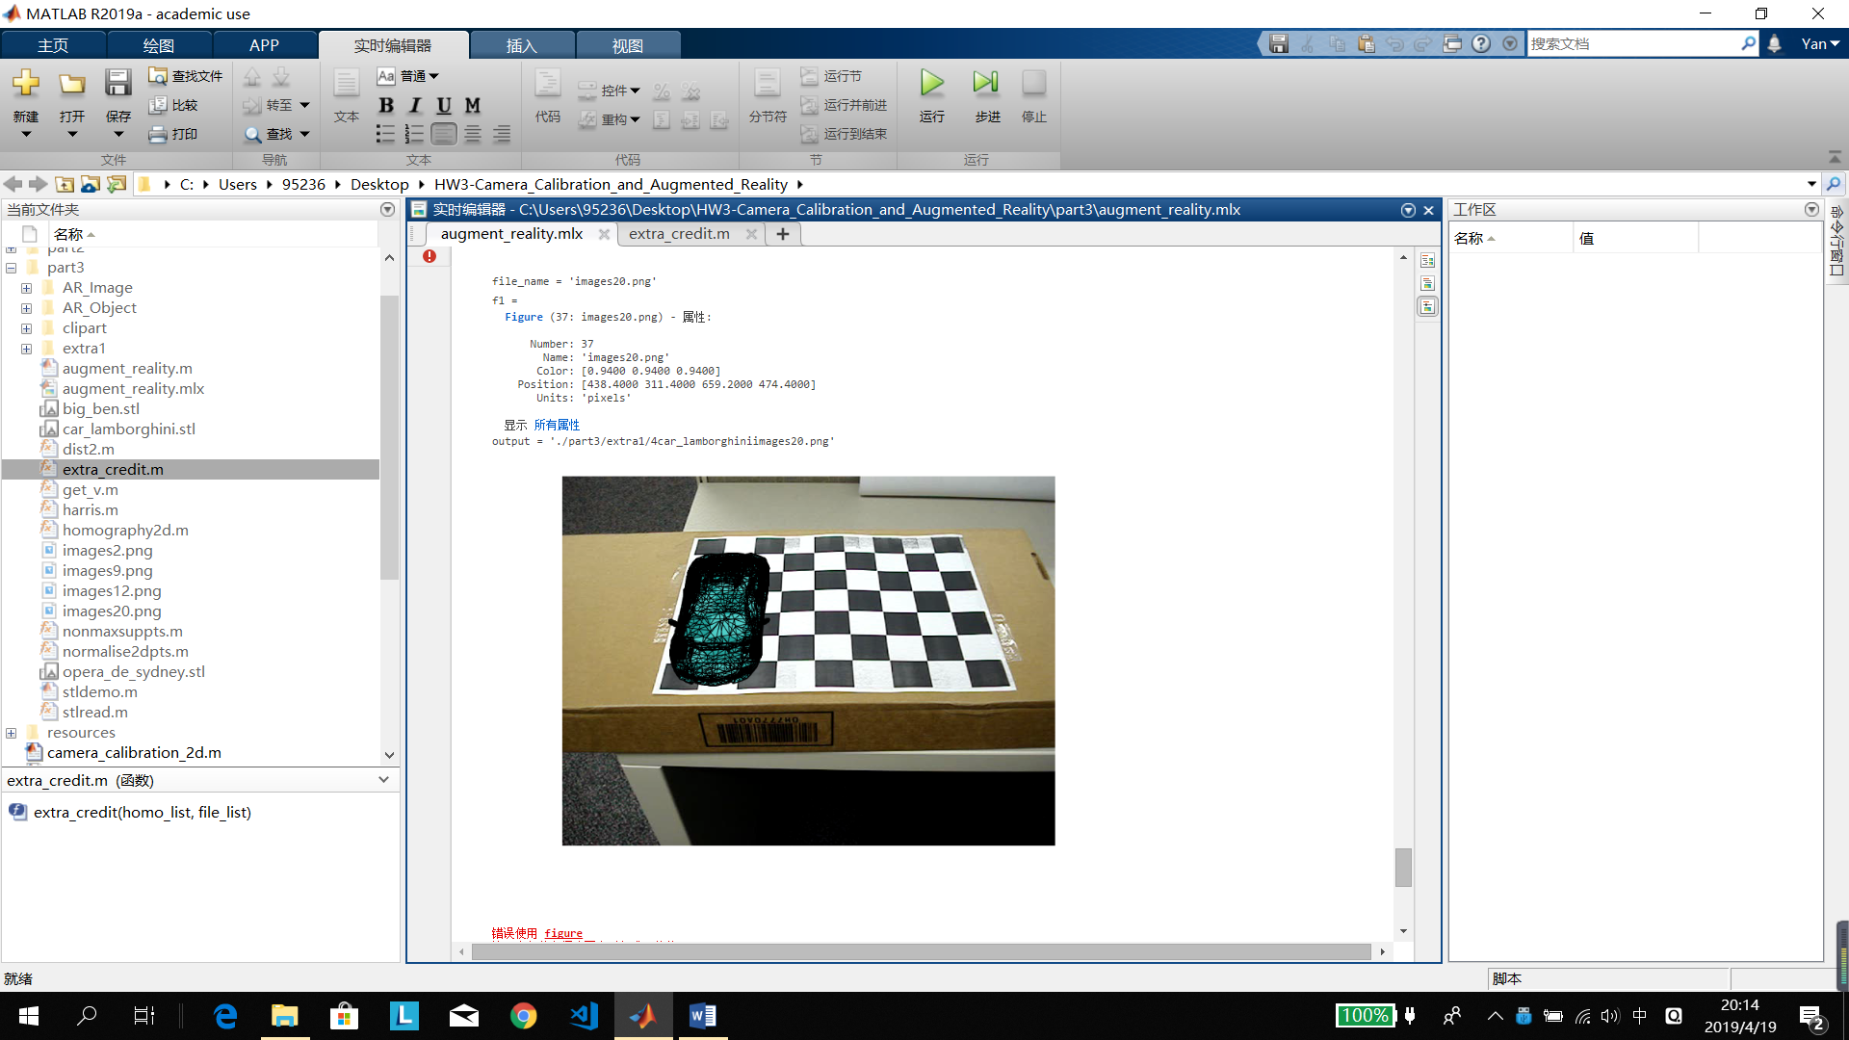

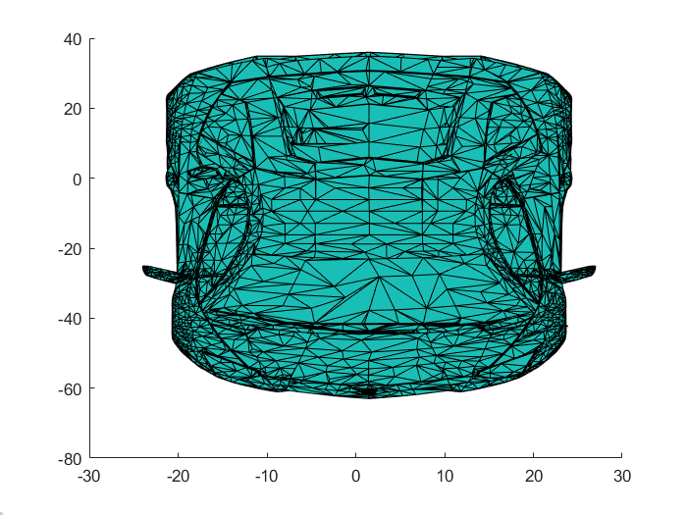

I also run other model as showing below: the Big Ben and the Sydney Opera House. (In extra1)

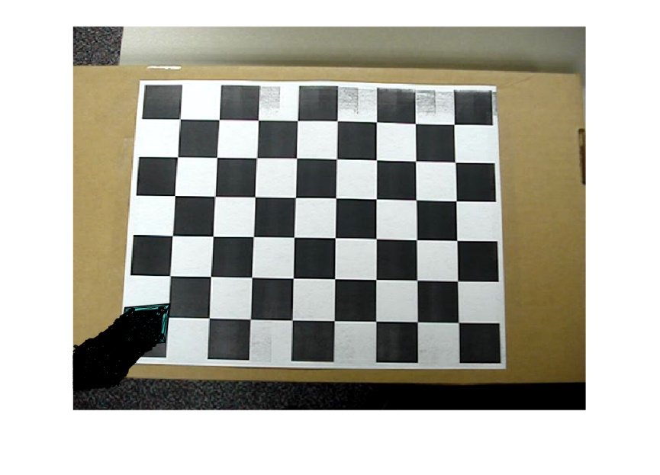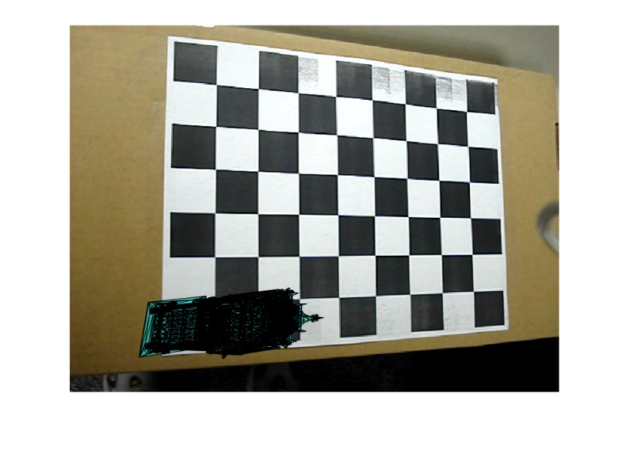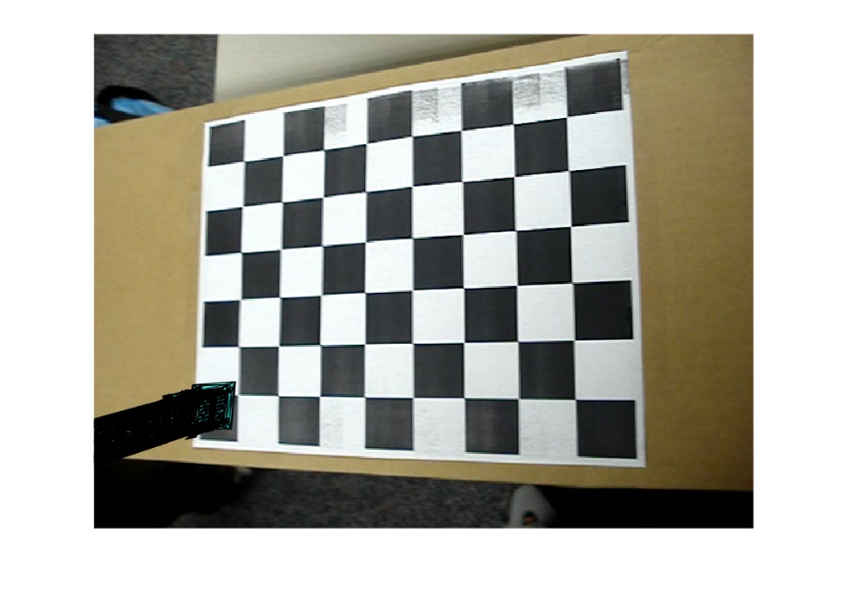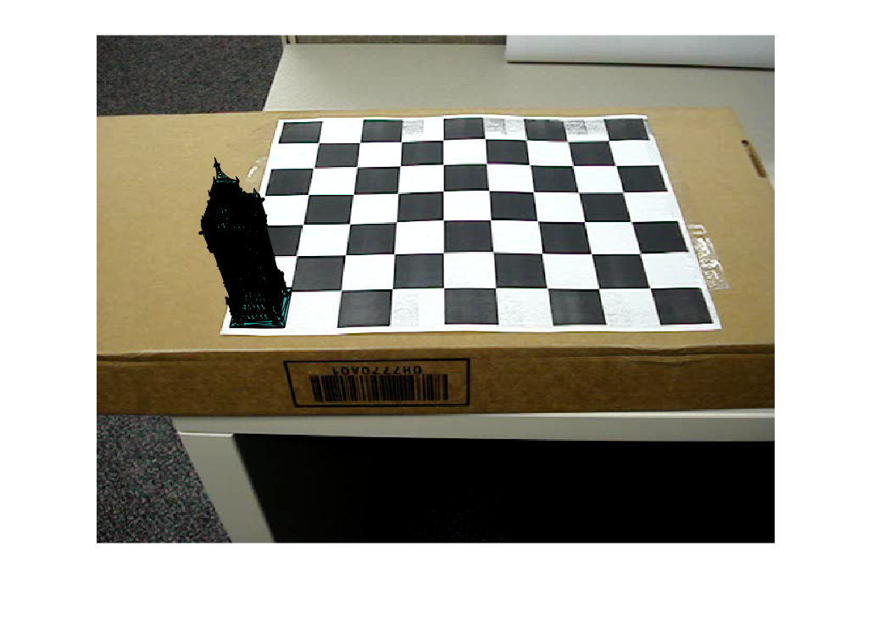

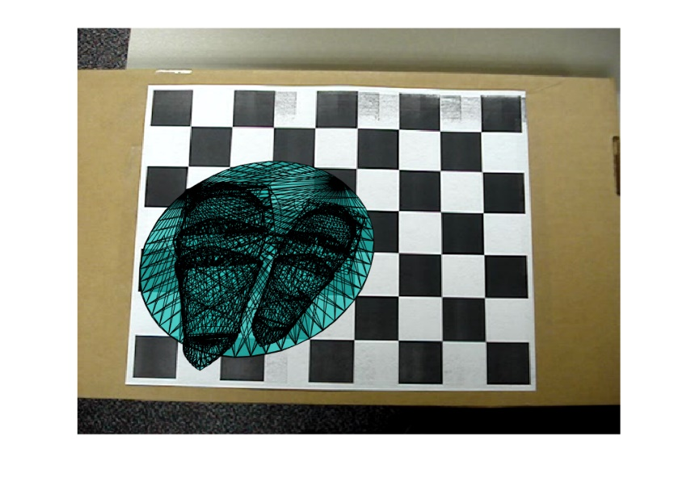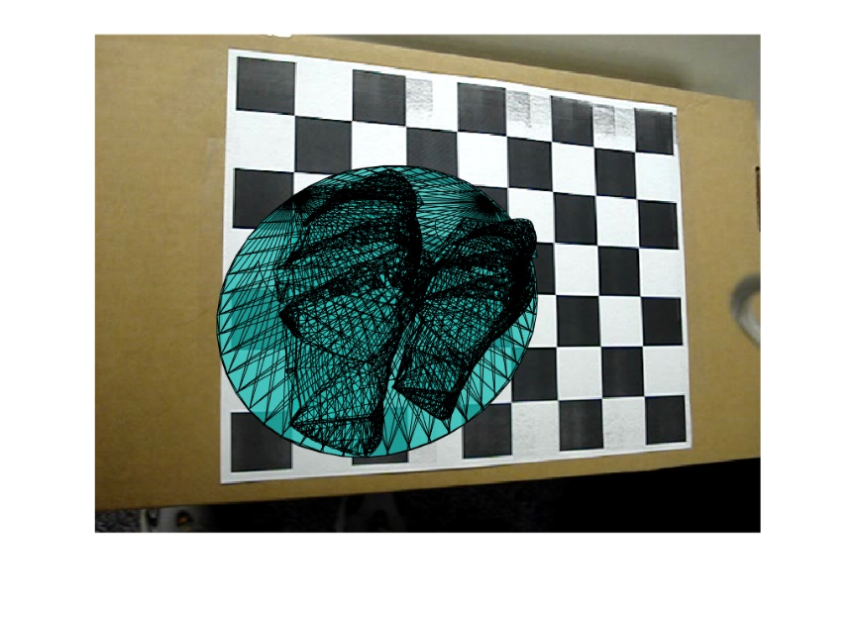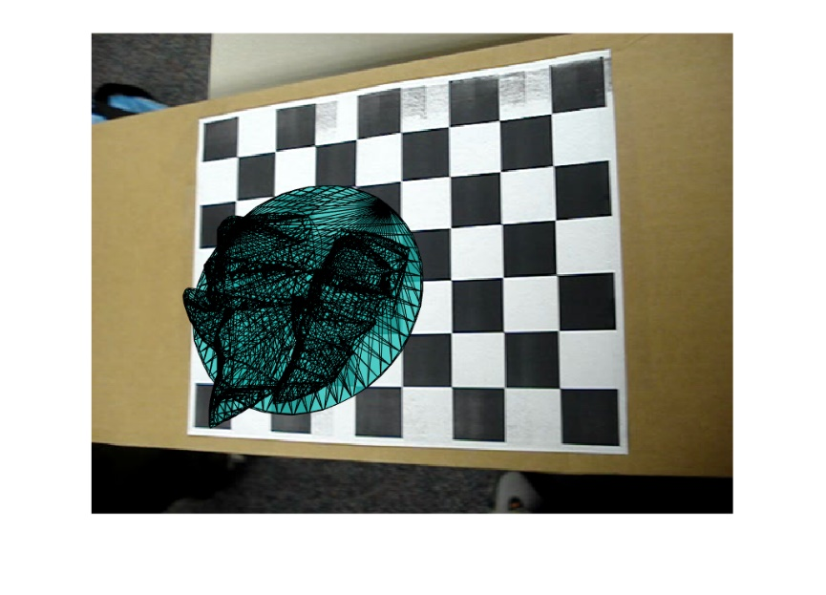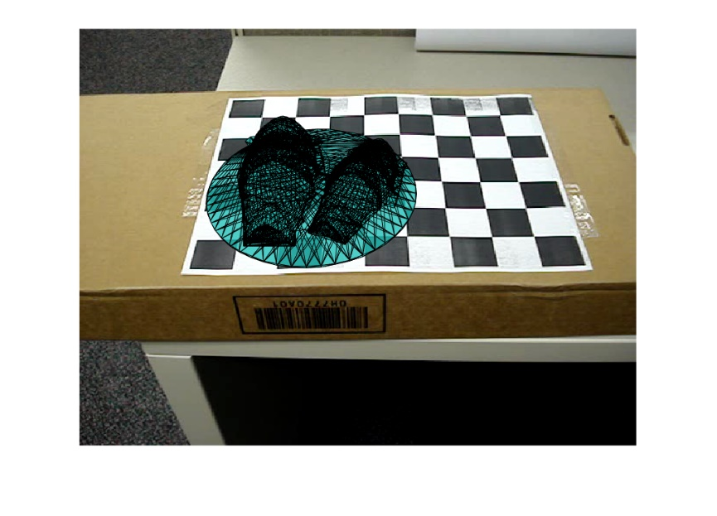

## Can you find a way to estimate the intrinsic and extrinsic parameters from only two images of the grid.

Estimate from only two images from the chapter given. If n = 2, we can impose the skewless constraint = 0, i.e., [0, 1, 0, 0, 0, 0]b = 0. That means we assume the pixels construct a rectangle.

The function is in the extra_credit.m and I just use image2 and image9 for calculating.

The results are in the next page.

